- The initial screen is displayed when the JASOnPDA application first starts up.

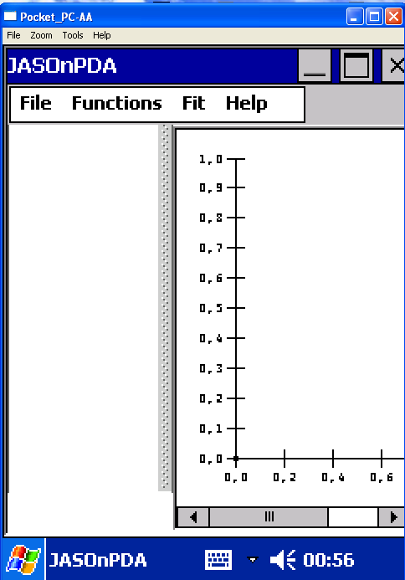

- The File menu can be used to ‘Open…’ a dialog box to enter the URL of the Clarens server.

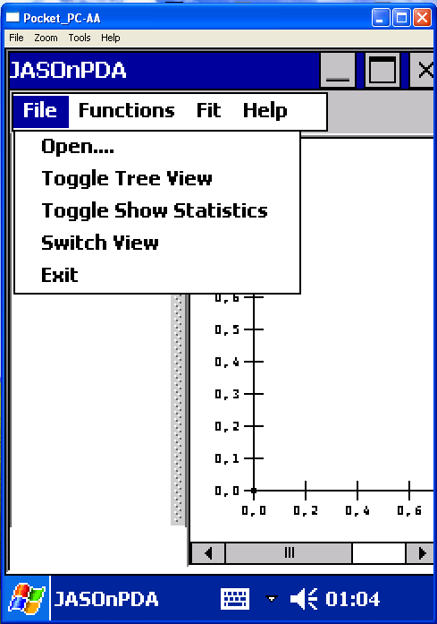

- The dialog box to enter the URL of the Clarens server pops up on selecting the Open.. menu option.

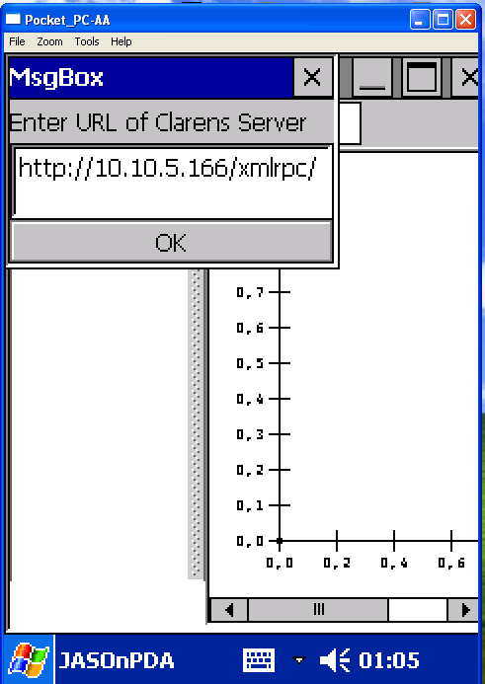

4. A dialog box then opens up which shows all the certificate and key files located in \Temp and allows the user to select his desired certificate and key file.
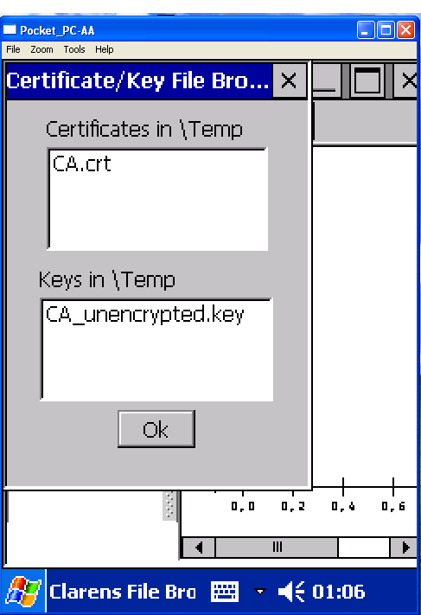

- The next dialog allows us to open the relative location of the directory (with respect to the Document Root) on the web server being used by Clarens, containing the ROOT files that we want to access. The dialog can be left empty to analyze files from the Document Root of the web server.

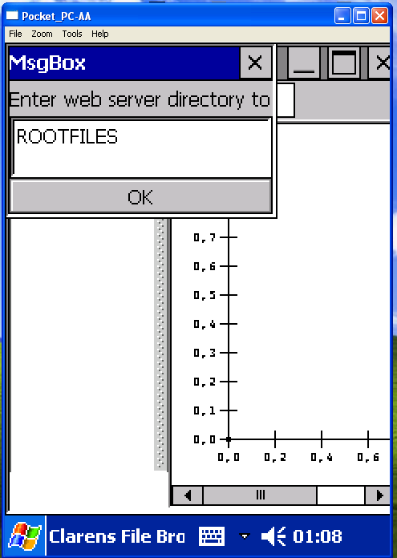

6. A dialog opens up showing all the files in the desired directory of the web server in use with Clarens.
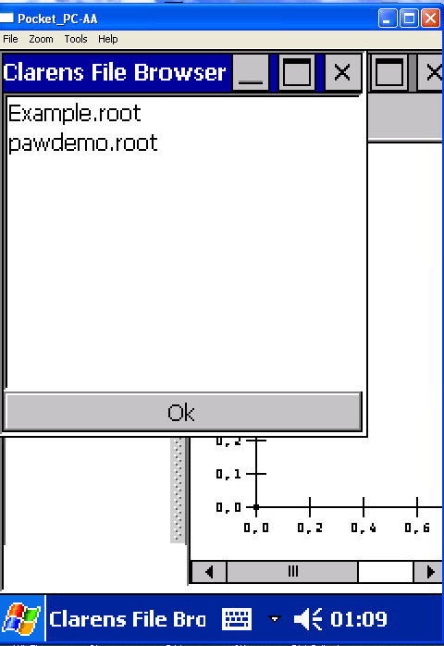

7.When any Root File in the Tree like Example. root is clicked; A tree structure representing the structure of the selected ROOT file opens up.

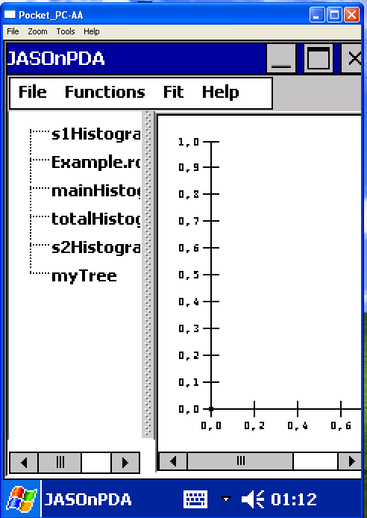

8.On selecting a histogram object, the histogram is displayed on the right pane.

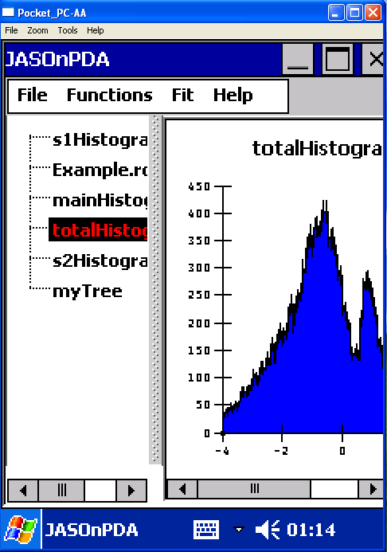

9. We can use “Toggle Tree view” to hide the Tree and show the Histogram on Whole PDA Screen.

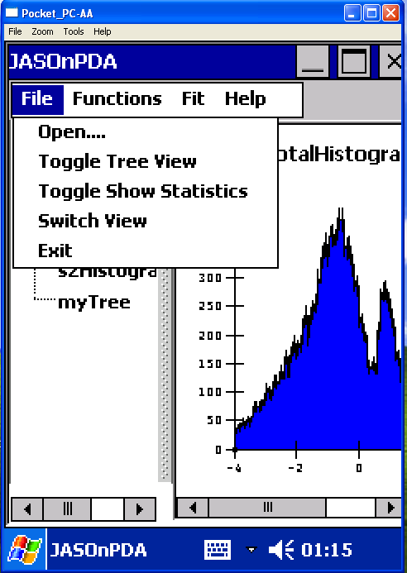

10. When we hide the Left Pane Tree(By using Toggle Tree view as in above screen ), the Whole Screen is for Histogram display.

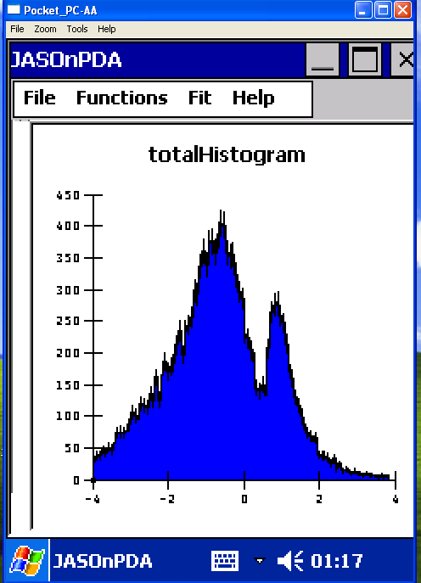

11. We can Use functions to draw any function on the Histogram.

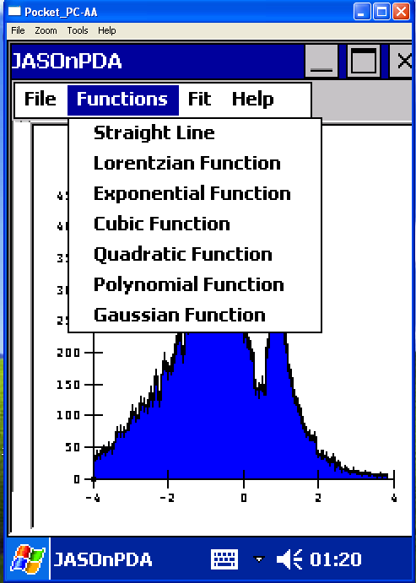

12. When we draw any function, it looks like below (It is not fitted yet. It will be fitted on Histogram when we click the Fit option under Fit).Under Fit, only those function are appearing, which has been applied on Histogram

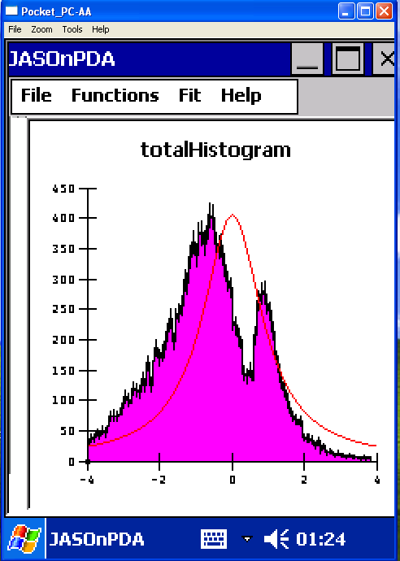

13. When we apply fit (Under Fit Menu), it exactly fits over the Histogram.

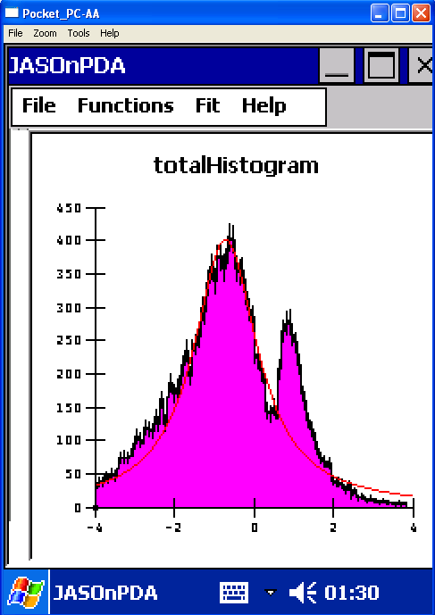

14. We can use the “Toggle Screen Statistics” under File Menu (Shown in Screen No.13) to show the statistics on the Histograms.

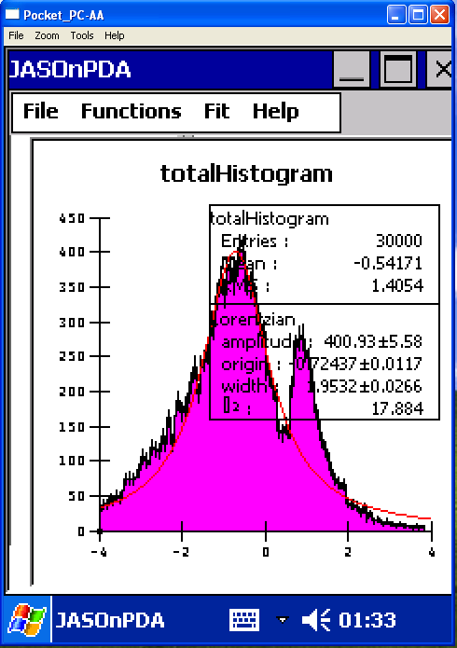

15. We can “Switch the View” Under File Menu (We can switch the view horizontally and vertically too…..Histograms list can be shown in left pane and in that case Histogram itself will be displayed in right pane…….in second case when switch view, List is in the upper pane where as Histogram is displayed in Lower pane as you suggested and is displayed below..)

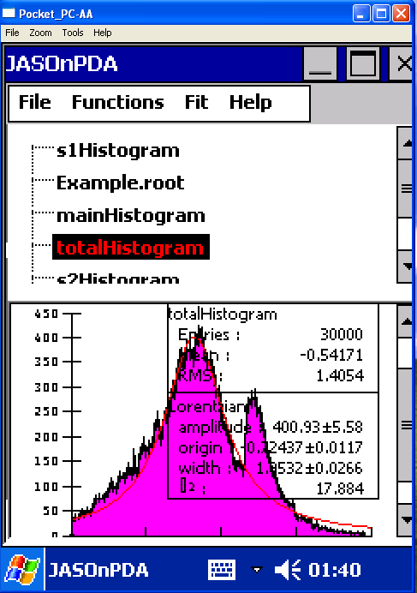

16. We can toggle the Tree again to hide the Tree which will appear again when we press the same (“Toggle Tree View”).

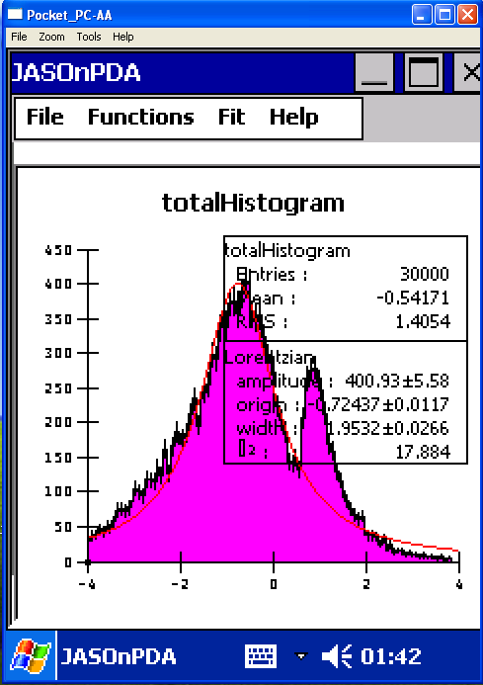

17. We can move the view again to Vertical by using the Switch View option under File.

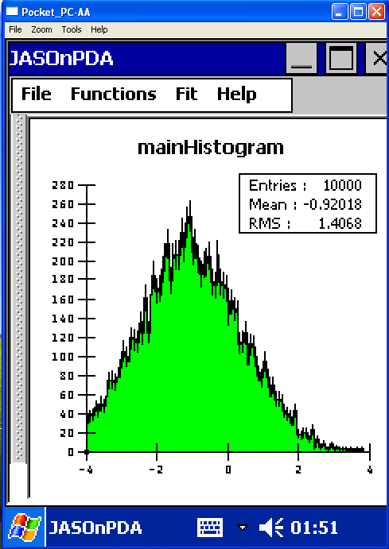

- We can disappear the Statistics Rectangle appearing over Histogram by clicking the “Toggle Show Statistics”.

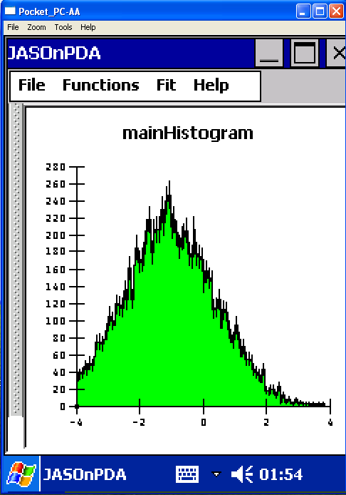

19. We can show the Left pane Tree as in the start by just clicking the “Toggle Tree View” Under File.
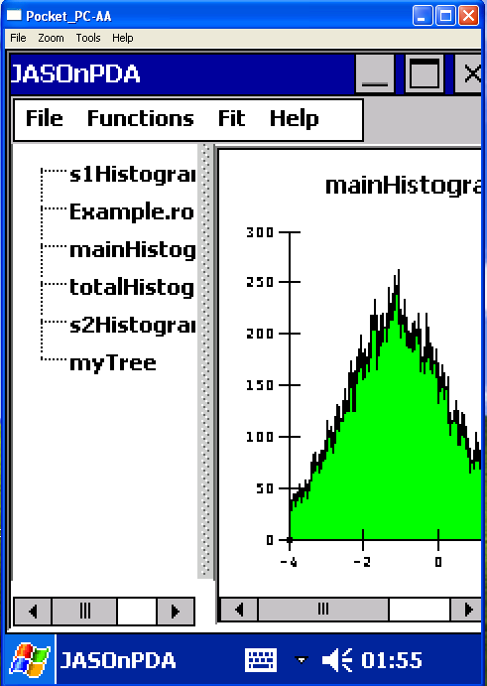

20. We can quit by using File->Exit Option.

