Hardware Base Technology Task
Contamination Transport

Final Report: Users Manual

Date 6/29/2007

Prepared by
Organization 354

For
Mars Technology Program

JPL Contract No. TBD (if applicable)

This document contains technical data as defined in the International Traffic In Arms Regulation (ITAR). Export of this material is restricted by the Arms Export Control Act (Title 22, U.S.C. 2751, at seq.) and is not to be exported to foreign persons without appropriate export authority.
Mars Lander Particle Contaminant Simulation Program
User’s Manual

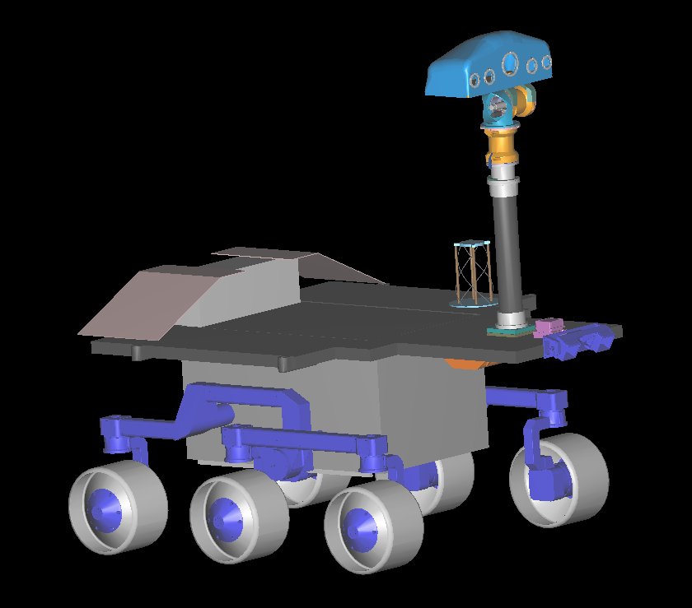
Mars Science Laboratory, Courtesy of JPL
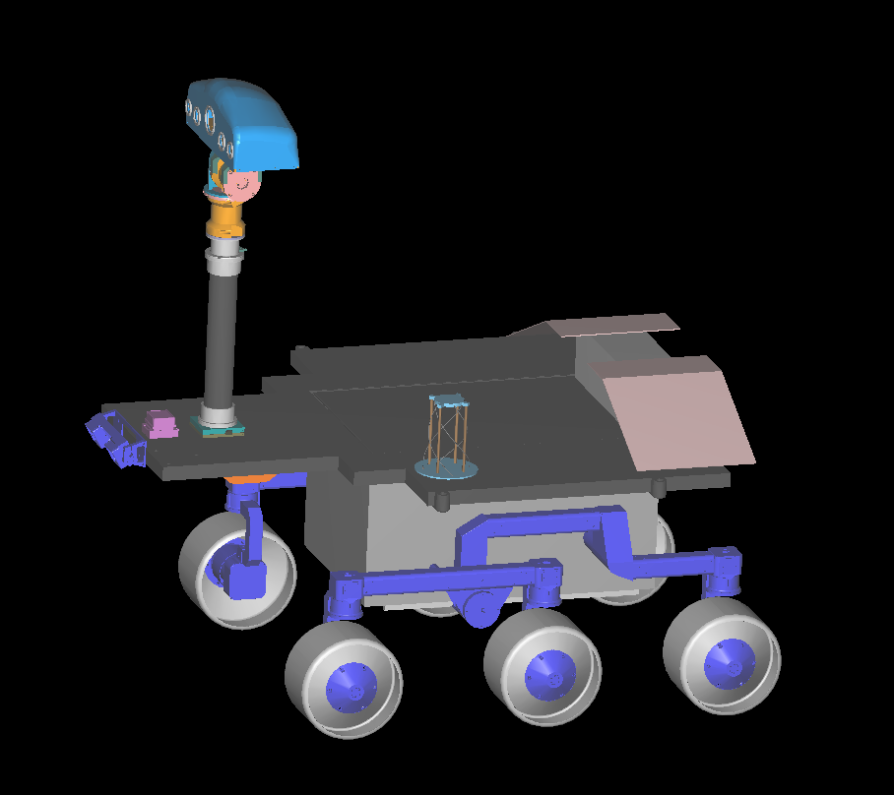
Mars Science Laboratory, Courtesy of JPL

Copyright, Acknowledgements, etc

Contents

Chapter 1: Program Overview 7
Chapter 1: Earth & Mars 8
i. Atmospheres 9
a. Earth 9
b. Mars 9
ii. Weather Patterns 11
a. Earth 11
b. Mars 11
iii. Wind Velocities 13
a. Earth 13
b. Mars 13
Chapter 2: Downloads & Installations 14
i. Java 15
ii. Java3D 15
iii. Mars Lander Particle Contaminant Simulation Program 15
Chapter 3: Configuration File 16
i. Environment 17
ii. Wind 18
iii. Debug 19
iv. Scale 19
v. Viscous Drag 19
vi. Particle Motion 20
vii. Normal Vectors 20
viii. Leading Edge Calculations 20
ix. Stagnation Points 21
x. Particle Tracks 29
xi. Clean Room Specifications 29
xii. Particle Size 30
xiii. Sigma Value 30
xiv. Particle Number 31
xv. Surfaces 31
xvi. Particle Density 32
xvii. Batch Mode 32
xviii. Experiments 32
Chapter 4: Starting the Simulation 34
Chapter 5: Graphical User Interface 38
i. Buttons 40
a. Top View 40
b. Side View 41
c. Zoom In 41
d. Zoom Out 41
e. New 41
f. Start/Stop 42
g. Hide Lander/Show Lander 42
h. Save View as JPEG 43
i. Write Data File 43
ii. Check Boxes 44
a. Debug 44
b. Show Particle Motion 44
c. Show Tracks 44
d. Show Image Every Step 44
iii. Sliders 46
a. Wind Speed 46
b. Wind Direction 46
iv. Simulation 46
Chapter 6: Data Analysis 48
i. Pictures 49
ii. Movies 49
iii. Data File 49
Appendix #: Contamination Transport and Flow 68
i. Title 68
Flow over a bluff body: 68
Appendix #: Functions 73
i. Class Lander 73
a. public Lander(String[] args) 73
b. public double nPerSquareMetre(double d, double dc) 73
c. public void takeSnapShot() 73
d. public BranchGroup createSceneGraph() 73
e. void recursiveGetShapes(Object value) 74
f. void destroyParticles() 74
g. void destroyStagnationNormals() 74
h. void setupTriangles() 74
i. void initializeSim() 74
j. void setupParticles() 74
k. public double LineLineDistance(Point3d p1, Point3d p2, Point3d p3, Point3d p4) 74
l. public Point3d GetIntersection(Point3d p1, Point3d p2, Triangle T) 74
m. public boolean SameSide(Point3d p1, Point3d p2, Point3d A, Point3d B) 75
n. public boolean CoplanarTriangles(Triangle T1, Triangle T2) 75
o. public boolean PointInTriangle(Point3d p, Triangle T) 75
p. void shapeSetup(Shape3D shape) 75
q. TriangleArray shapeGetTriangles(Shape3D shape) 75
r. public static double erf(double z) 75
ii. Class Triangle 76
a. Triangle(Point3d v1, Point3d v2, Point3d v3, Vector3f _normal) 76
b. String print() 76
c. void setNeighbours(int _nn, int _n[]) 76
d. void setStagnation(Point3d CofM) 76
iii. Class Blob 77
a. Blob (String _name, int _type, double X, double Y, double Z, double Vx0, double Vy0, double Vz0, double M0, int _itriangle, double _radius, Color3f _color) 77
c. void update() 78
d. public void processStimulus(Enumeration criteria) 78
e. public class eventHandler implements ActionListener 78
f. void writeResults() 78
Appendix #: VRML Shapes 80
i. Cube 80
ii. Pyramid 80
iii. Torus 81
Index 83

Chapter 1: Program Overview

The Mars Lander Particle Contaminant Simulation Program is designed to simulate microparticle behaviors ranging in size and density in different conditions, specifically the default atmospheres of either Earth or Mars. This program defines several characteristics of both Earth and Martian environments including wind speeds and directions, air density and viscosity, atmospheric temperature and pressure, and gravity. Additionally, the user is able to create his or her own atmospheric conditions for the simulations.
Using numerous Java classes and methods, the Mars Lander Particle Contaminant Simulation Program creates a real-life particle distribution over any given geometry including the default Mars Science Laboratory, hereinafter referred to as MSL. Each function will be further discussed in the following sections. An output file containing the particle positions after the simulation can be utilized by the user to create several plots such as a particle distribution on the planet’s surface as well as particle detachment probabilities according to size and/or density.
For a complete description of the theory behind the Mars Lander Particle Contaminant Simulation Program, please refer to the Appendix.

This user’s manual describes the numerous capabilities of the Mars Lander Particle Contaminant Simulation Program. Likewise, the conditions on both Earth and Mars are briefly explained to justify the characteristics of the simulation.

Chapter 1: Earth & Mars

This chapter describes the weather and atmospheric conditions on both Earth and Mars. These conditions are applied to the simulation for both of the environment default options. Below is a list of the weather criteria specified in the default atmospheres:

- Air viscosity
- Air density
- Gravity
- Temperature
- Pressure

Earth & Mars

The Mars Lander Particle Contaminant Simulation Program provides two default environments: Earth and Mars. The atmospheric properties for each planet were defined in the program’s default settings. Likewise, the weather and wind tendencies were incorporated into the program by creating accurate weather patterns for each planet.

i. Atmospheres

a. Earth

The atmospheric data for Earth can be seen in Table 1.i.a.1. The units for density, ρ, are kg/m³; kinematic viscosity, ν, are m²/s; gravity, g, are m/s².

Table 1.i.a.1: Earth’s Atmospheric Conditions
Density | Kinematic viscosity | Gravity
1.293 | 0.000015 | 9.80665

The kinematic viscosity of Earth’s atmosphere can also be expressed by Equation 1.i.a.1 as a function of temperature and pressure.

Equation 1.i.a.1

Here, η_{air} is expressed in Equation #.i.a.2.

Equation 1.i.a.2

In Equation 1.i.a.2, the units of temperature are Kelvin, , and .

b. Mars

Atmospheric conditions for Mars are shown in Table 1.i.b.2. The units for density, ρ, are kg/m³; kinematic viscosity, ν, are m²/s; gravity, g, are m/s².

Table 1.i.b.2: Mars’ Atmospheric Conditions
Density | Kinematic viscosity | Gravity
0.02563 | 0.000561 | 3.726527

The kinematic viscosity of Mar’s atmosphere can also be expressed by Equation #.i.b.1 as a function of temperature and pressure.

Equation #.i.b.1

Here, η_{CO2} is expressed in Equation #.i.b.2.

Equation #.i.b.2

In Equation #.i.b.2, the units of temperature are Kelvins, , and .

ii. Weather Patterns

a. Earth

Many of Earth’s weather patterns can be attributed to its tilt and its dense atmosphere. Earth’s profound tilt through the North and South poles causes the sun to heat Earth’s surface unevenly. This causes cold and warm fronts of low and high pressure air to travel in the direction of the planet’s rotation. Earth’s dense atmosphere and large bodies of water help prevent sudden temperature changes by absorbing and trapping heat.
A satellite image of Earth can be seen below.


Figure 1 Earth (courtesy www.jpl.nasa.gov)

b. Mars

The weather conditions on Mars are present largely in part to its tilt and thin atmosphere. The tilt is responsible for cold and warm front behaviors similar to those on Earth. These fronts are responsible for strong temperature changes. Likewise, because Mars has no known bodies of water of substantial sizes and the air is very thin, the heat produced by the sun is not easily absorbed. Instead, the dust on the surface and in the atmosphere traps the heat. Increased temperatures create volatile wind patterns including cyclones and dust storms. In 1999, an area of Mars was plagued by a cyclone during the summer that stretched more than 1000 miles across. A dust storm in July of 2001 covered the entire planet for several months.

Several satellite images of Mars can be seen in the Figure below. The wind patterns can be seen. Note that the dark circle on the Mar’s South Pole is due to a lack of light in that area when the images were taken.

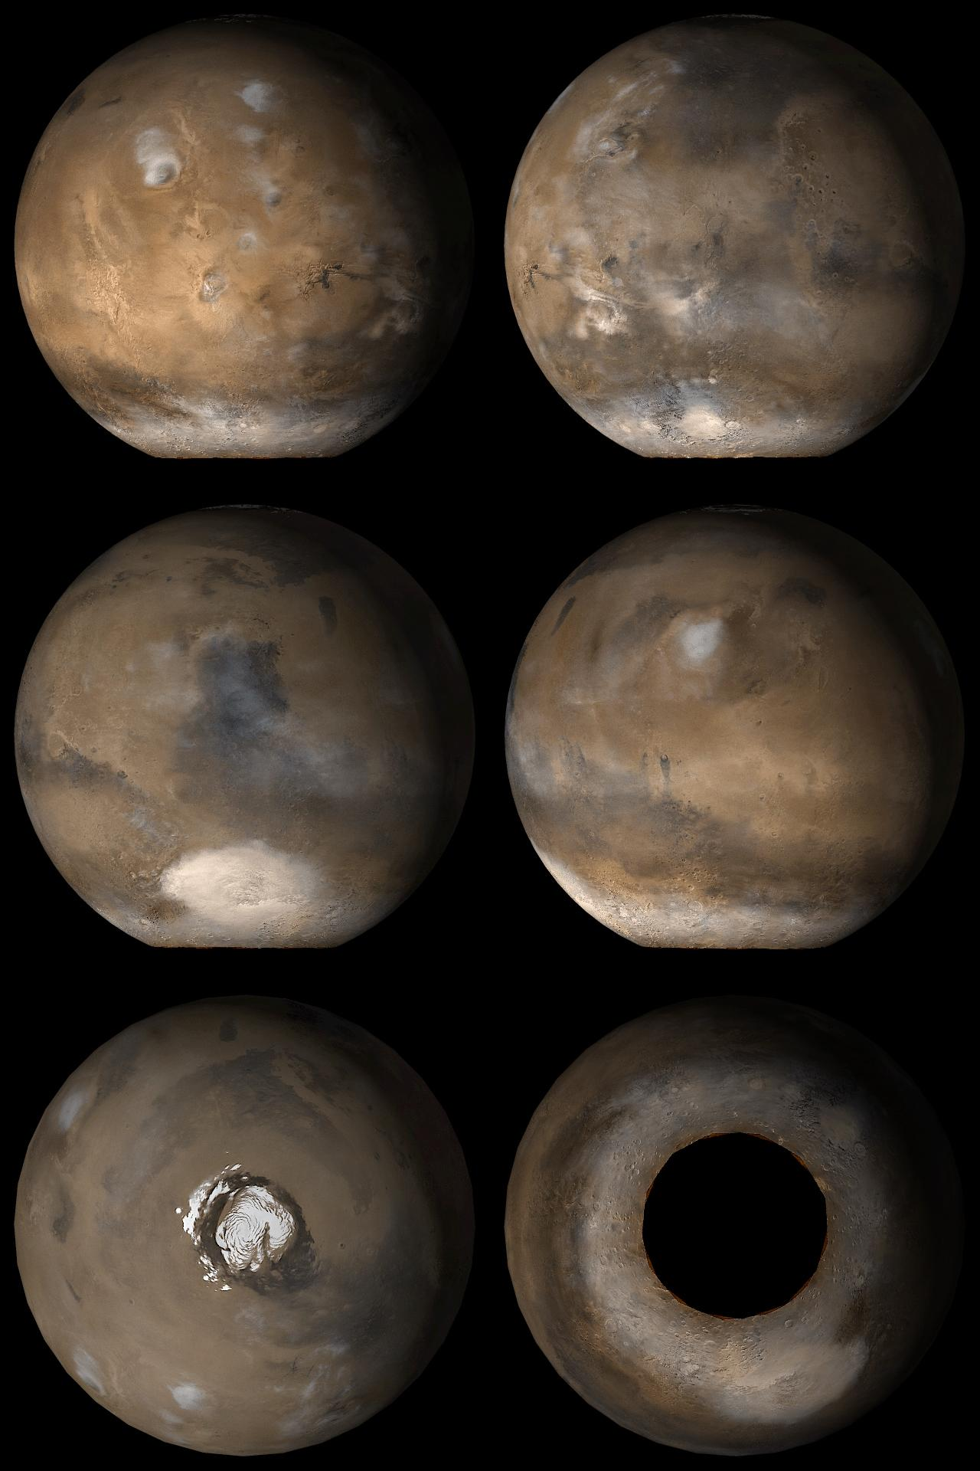
Figure 2 Images of Mars (courtesy JPL)

Chapter 2: Downloads & Installations

This chapter includes instructions needed for the downloads required to run the Mars Lander Particle Contaminant Simulation Program.
Below is a complete list of the required downloads:

- Java
- Java 3D
- Mars Lander Particle Contaminant Simulation Program and associated files (one zipped distribution file)

In order to run the Mars Lander Particle Contaminant Simulation Program, the user must first download and install both Java and Java3D.

i. Java

To download Java, visit http://java.sun.com/javase/downloads/index.jsp. Select the latest “Vanilla JDK,” or Java SE Development Kit. The user does not need to download any extras including “EE” and “NetBeans.” Follow the installation instructions provided.

ii. Java3D

To download Java3D, visit https://java3d.dev.java.net/binary-builds.html. The user is to select the appropriate and latest Java3D kit for his or her machine. The user is cautioned if he or she has Java setup for automatic updates (the default), a new version of Java will automatically be installed when available. Therefore, the user will need to re-install Java3D manually following the instructions provided above.

iii. Mars Lander Particle Contaminant Simulation Program

To obtain the necessary files for the Mars Lander Particle Contaminant Simulation Program, download the zipped simulation file from http://pcbunn.cacr.caltech.edu/Mars/Lander_v2.0.zip. Create a directory titled “Mars Lander” in the “Local Disk (C:)” drive and unpack all the files in the zip file into it. The “Local Disk (C:)” drive can be found under “My Computer.” The user now has all of the files required to run the Mars Lander Particle Contaminant Simulation Program.

After completing these downloads, the user is directed to Chapter 3 to begin making specifications for the simulation.

Chapter 3: Configuration File

After downloading and installing the required software as described in Chapter 2, the user is now ready to specify atmospheric conditions and utilize the options the program offers for the simulations.

This chapter contains a complete description of the configuration file that is to be created by the user to set the parameters for the simulations. Several example files are provided in the downloaded kit. The configuration files are of type “.cfg” by convention (although this is not a requirement).

Below is a list of options featured in the configuration file. These options are explained fully in this chapter.

- Environment
- Wind
- Debug
- Rolling Viscous Drag
- Particle Motion
- Normal Vectors
- Leading Edge Calculations
- Stagnation Points
- Clean Room Specifications
- Batch Mode
- Experiments

An example configuration file for the Mars Lander Particle Contaminant Simulation is shown below

# Configuration file for Mars Lander Particle Contaminant Simulation
# Comments lines begin with a "#" and are ignored, like this one
VRML: Rover_Top_Assy_MrSR-TX-ASM.wrl
OUTPUT: test.data
# Environment can be Mars or Earth
ENVIRONMENT: Earth
# wind parameters are triplets specified as (T,S,D)
# where T=time (secs), S=speed (m/s), D=direction angle (degrees)
WIND: (0,5.0,90)
# DEBUG printout (very copious)
DEBUG: OFF
# SCALE factor that converts numbers in VRML file to Meters
SCALE: 0.00228
# VISCOUS ON to calculate effect of Viscous Drag
VISCOUS: ON
# MOTION ON to show particle moving over surfaces, and falling to planet surface under gravity.
# MOTION OFF just calculates final particle positions and places them there
MOTION: ON
# NORMALS ON to show surface normals
NORMALS: OFF
# LEADING ON to calculate leading edge to wind and liftoff
LEADING: ON
# STAGNATION ON to show stagnation points of surfaces in wind
STAGNATION: OFF
# TRACKS ON to show the tracks across surfaces particles will follow
TRACKS: OFF
# CLEANROOM value specifies the cleanliness level of the surfaces. E.g. value=100 signifies 100 micron cleanroom
CLEANROOM: 100
# PARTICLESIZE (overrides CLEANROOM) specifies the mean value of the Gaussian used to generate the size of the particles (microns)
#PARTICLESIZE: 128
# PARTICLESIGMA specifies the sigma of the Gaussian distribution for the sizes of the particles used (microns)
#PARTICLESIGMA: 20
# PARTICLENUMBER (if PARTICLESIZE non-zero) specifies number of particles to generate per square meter
#PARTICLENUMBER: 200
# PARTICLEDENSITY value specifies the density of the contaminant particles (kg/m^3)
PARTICLEDENSITY: 1000
# SURFACES [ALL|TOP|SIDE] indicates which model surfaces are to be sprinkled with particles (this
# specification is ignored if using CLEANROOM particles)
SURFACES: ALL
# BATCH ON to immediately run simulation and exit when complete
BATCH: OFF
# EXPERIMENTS n to run n experiments
EXPERIMENTS: 1
Below is a complete description of each option and its parameters. Note that the displayed option is the suggested response for the given option in order to create a quick and accurate simulation on Mars.

i. Environment

The Environment option allows the user to choose the desired environment. Two responses exist for this option: “Earth” and “Mars” where the “Earth” response runs the simulation in the Earth atmosphere and the “Mars” response creates a Martian atmosphere. Refer to the code below for an illustration of the ENVIRONMENT prompt.

# Environment can be Mars or Earth
ENVIRONMENT: Mars

ii. Wind

The Wind option allows that user to create a series of wind vectors to model a given weather pattern. The wind parameters are entered into the configuration file as a set of triplets specified as (Time, Speed, Direction).

The minimum time, in the program’s sense of time, it takes for a change in wind direction is 0.001 seconds. Therefore, if the “Motion” setting, described below, is turned OFF, any amount of time greater than 0.001 seconds is suitable between changing wind vectors.

The direction specified by the third number in the triplet set refers to the angle between the wind vector and the vertical.

# wind parameters are triplets specified as (T,S,D)
# where T=time (seconds), S=speed (meters/second), D=direction angle (degrees)
WIND: (0,2,0) (2,0.2,15) (4,0.8,30)

While the above method of defining a wind vector may be suitable for certain simulations, another option exists. In this case, the user is able to specify a continuously changing wind vector. In this method only one triplet is used and the user is able to specify increments to the wind direction and speed by the use of negative values. See the example below.

WIND: (-0.01,5,-10)

The above triplet represents a wind vector that will maintain a constant wind speed of 5 meters per second (as denoted by the positive number 5). After every 0.01 seconds, the wind will change direction by 10 degrees. These increments are denoted by negative signs. Another example can be seen below.

WIND: (-0.01,5,-10)

The above triplet specifies a wind that will increase its speed in 0.01 second increments while maintaining an angle of 90 degrees with the x-axis. Note that the time and speed values are negative, indicating that these are the incremented values. The direction value is positive indicating that it remains constant. A final example is shown below where all values are changing.

WIND: (-0.1,-10,-10)

The above triplet describes a wind that changes both speed and direction every 0.1 seconds. Both the speed and direction change in increments of 10 so that at 0 seconds, both the speed and direction are zero, at 0.1 seconds, the speed is 10 meters per second with a direction of 10 degrees, at 0.2 seconds the velocity is 20 meters per seconds with an angle of 20 degrees, and so on.

iii. Debug

The Debug option allows the user to print out the details of the simulation while it is running, including area calculations as well as information for every particle and wind vector, or to suspend it. Two options exist for this command: “ON” and “OFF.” “ON” will create a printout whereas “OFF” will not. The user should be aware that the Debug option, when turned on, is very copious and may slow the simulation. Refer to the code below for an illustration of the DEBUG prompt.

# DEBUG printout
DEBUG: OFF

iv. Scale

The Scale option allows the user to convert and scale the dimensions in the geometric shape VRML file. For example, if the units in the VRML file are inches, the scale option can convert them to meters for the simulation given the appropriate conversion factor. Refer to the code below for an illustration of a scaling conversion from inches to meters.

# SCALE factor that converts numbers in inches in VRML file to Meters
SCALE: 0.0254

Another example is shown below for a scaling conversion from feet to meters.

# SCALE factor that converts numbers in feet in VRML file to Meters
SCALE: 0.3048

v. Viscous Drag

The Viscous Drag option allows the user to turn the drag due to the atmosphere on or off. Two options exist for this command: “ON” and “OFF.” If the viscous drag is turned “ON,” it will be taken into consideration for all calculations. If turned “OFF,” the drag between the particle and the atmosphere will be ignored, hence creating an “ideal” environment, as if in a vacuum. For the most accurate results, the viscous drag must be turned on for environments having atmospheres. For bodies with extremely thin atmospheres such as Earth’s moon, the viscous drag should be turned off.

VISCOUS: ON

vi. Particle Motion

The Particle Motion option allows the user to view the motion of each particle as it travels along the geometric surface and after it detaches. Two options exist for this command: “ON” and “OFF.” “ON” will show each particle’s motion as it moves across the surface and then falls to the planet’s surface. If the user wishes to gather data of particles while they are falling to the surface, this feature must be turned on.

“OFF” will instantly move each particle to the trailing edge of the geometric surface and then immediately again to its point of impact with the surface. This point will be calculated directly and, therefore, this option is suggested as it will allow the program to run faster. Neither option will compromise the validity of the results. Refer to the code below for an illustration of the PARTICLE MOTION prompt.

# MOTION
MOTION: OFF

vii. Normal Vectors

The Normal Vectors option allows the user to display normal vectors on each area of the geometry. Two options exist for this command: “ON” and “OFF.” “ON” will display the normal vectors on each surface area. The normal vectors allow for a better perspective on the depth and position of each component, especially for complex geometries. “OFF” will not draw the normal vectors. This option is suggested because it eliminates extra lines within the simulation window. Likewise, it allows the program to run faster as it avoids extra calculations. Neither option will compromise the validity of the results.

# NORMALS
NORMALS: OFF

viii. Leading Edge Calculations

The Leading Edge Calculations option allows the user to suspend calculations used to find the distance between the particle and leading edge. There are two options for this prompt: “ON” and “OFF.” When turned “ON,” the distance between the particle and leading edge is calculated. However, when “OFF” this calculation is not performed. It is highly recommended that this option is “ON” during every simulation as this distance is used in the detachment fraction found by Partha Shakkottai and Jackie Grimes.

Suspending the calculation will cause all particles to detach from the geometric surface. Therefore, suspending the leading edge calculation will create inaccurate data if the user is analyzing the detachment of microparticles from the geometric surface.

# LEADING ON to calculate leading edge to wind and liftoff
LEADING: ON

ix. Stagnation Points

The Stagnation Points option allows the user to display the wind stagnation points on each area of the geometry. Two options exist for this command: “ON” and “OFF.” “ON” will display the wind stagnation point on each surface area. The stagnation point is calculated to be the center of mass of a given shape. “OFF” will not draw the wind stagnation points. This option is suggested because it eliminates extra points within the simulation window. However, even when the wind stagnation points are not displayed, they are still calculated in order to determine the direction in which the particle will travel given a specific wind vector and the angle it makes with the geometric surface. Neither option will compromise the validity of the results.

# STAGNATION
STAGNATION: OFF

In order to determine if a particle will become dislodged from the geometric surface, the Mars Lander Particle Contaminant Simulation Program calculates the angle made between the wind vector and the plane of the geometric surface on which the particle sits. As seen in the Figure below, when the wind is parallel to the surface, the particle detaches with the same velocity as the wind vector. Flow like this occurs on a solar panel facing the wind edge on, for example.

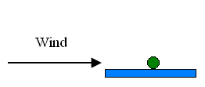
Figure 3 Wind acts parallel to the surface; detachment occurs and particle travels in the direction of the wind vector

In contrast, in the following Figure the wind acts at an angle less than 45º to the surface also causing the particles to become dislodged. The path the particles take in Figure 3.9.2 represents their behavior in reality.

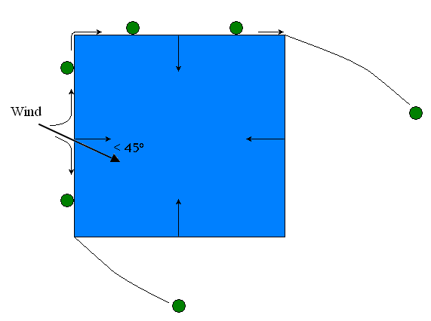
Figure 4 Process that occurs in reality; wind, depicted by a bold arrow bearing on the left face, acts at an angle less than 45º from the inward normal; arrows within box represent inward normal vectors; the wind radiates at the stagnation point along the face in the direct wind stream; air flow is attached at top left corner and detaches at bottom left and top right corners; particles move around box in motion outlined by green circles

For simplicity and because negligible error is created, the Mars Lander Particle Contaminant Simulation Program does not model the particle flowing around the surfaces of the box. Instead, the particles detach at the corners of the box and travel in the manner illustrated below.
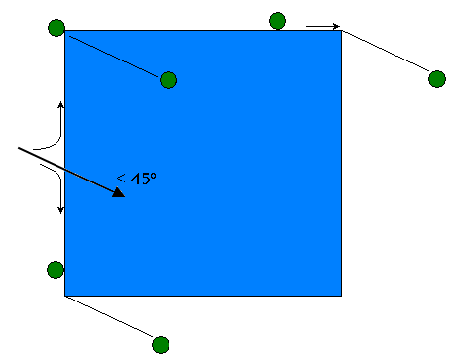
Figure 5 Process that occurs in simulation; wind, depicted by a bold arrow bearing on the left face, acts at an angle less than 45º from the inward normal; particles detach at corners and travel in the direction of the wind; particle motion through box occurs fo r simplicity and creates negligible error in the position of the particle when it lands on the planet’s surface; inward normal vectors on surface of box are removed only from drawing for simplicity but are considered in the simulation code and calculations; particle detachment on the face in the direct wind stream occurs under circumstances outlined in the previous Figure

The next Figure epicts the path each particle will take in the simulation when the wind vector acts at an angle less than 45º to the surface. It can be seen that the particles will travel radially outward from the stagnation point on the face that is directly in the wind stream. It is noted that the radial wind velocity vectors are a real-life occurrence and are modeled in the simulation.

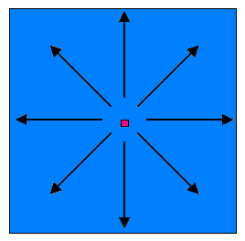
Figure 6 Top view of the face of a geometric figure; particles travel radially outward from pink stagnation point under winds that act 45º from the vertical on the surface; this pattern occurs only on the face that is directly in the wind stream

In order to determine the speed at which the particle will leave the surface at the trailing edge, a ratio of distances and speeds is used. This can be seen in Equation 3.9.1, where U_{p} is the particle speed, U is the wind speed, l_{s} is the distance between the particle and stagnation point along the particle detachment path, and L is the distance between the stagnation point and the trailing edge along the particle detachment path.

Equation 3.9.1

An illustration of the variables in Equation 3.9.1 can be seen in Figure 3.9.5.

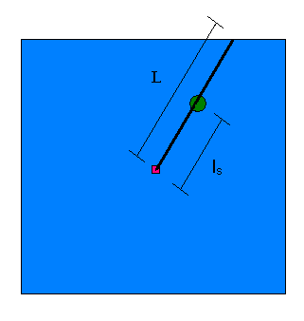
Figure 7 An illustration of variables; ls is the distance between the particle and stagnation point along the particle detachment path and L is the distance between the stagnation point and the trailing edge along the particle detachment path; the pink square represents the stagnation point and the particle is represented by a green circle

In the following Figure the wind acts at an angle greater than 45º to the surface also causing the particles to become dislodged. The illustration corresponds to particle behavior in reality.

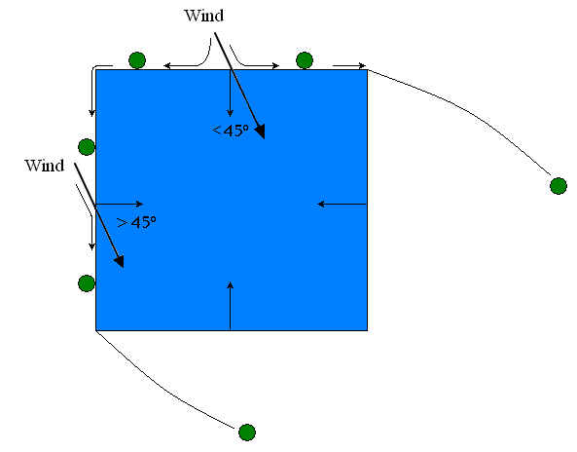
Figure 8 Process that occurs in reality; wind, indicated by a bold arrow bearing on the left and top faces, acts at an angle greater than 45º from the inward normal on the left face and therefore acts at an angle less than 45 º from the inward normal on the top face; arrows within box represent inward normal vectors; flow is attached at top left corner and detached at both the bottom left and top right corners; particles move around box in motion outlined by green circles

It can be seen above that the particles move around the surface of the box until becoming dislodged from the surface. This, however, is not the case in the simulation. Instead, the particle detach at the corners of the box and travel in the direction of the wind. Refer to the next Figure:
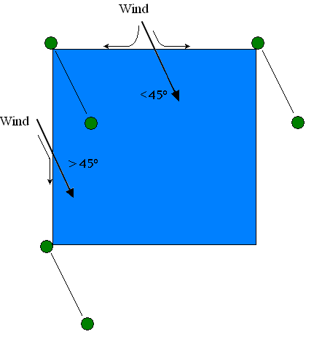
Figure 9 Process that occurs in simulation; wind, indicated by a bold arrow bearing on the left and top faces, acts at an angle greater than 45º from the inward normal on the left face and therefore acts at an angle less than 45 º from the inward normal on the the top face; particles detach at corners of box and follow the direction of the wind at the top and bottom left corners while the particles on the top right face travel horizontally off of the box; particle motion through box occurs for simplicity and creates negligible error in the position of the particle when it lands on the planet’s surface; inward normal vectors on surface of box are removed only from drawing for simplicity but are considered in the simulation code and calculations

While the particle motion is not identical to that in the real-life case the subtle differences create negligible errors in the final positions of the particles upon landing on the planet’s surface.

The realistic case for wind acting perpendicular to the surface is shown below
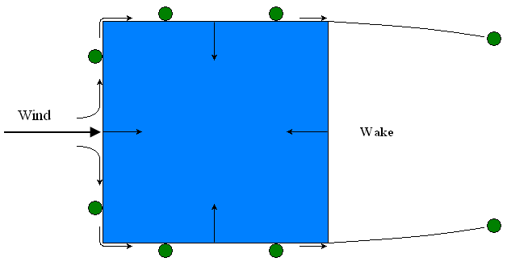
Figure 10 Process that occurs in reality; wind, indicated by a bold arrow bearing on the left face, acts normal to the surface; arrows within box represent inward normal vectors; flow is attached at both the top and bottom left corners and is detached at both the top and bottom right corners; particles move around box in motion outlined by green circles; a wake is present at the right face, the face downstream to the airflow

It can be seen that the particles travel along the box and bend around both the top and bottom left corners until ultimately becoming dislodged at the top and bottom right corners. Because the wind acts normal to the leading face of the box, a wake is formed at the trailing face of the box. In this case there is no difference between reality and simulation: in both cases the particles end up at the same positions on the surface.

x. Particle Tracks

The Particle Tracks option allows the user to view the path each particle will follow as it travels across the geometric surface. Two options exist for this prompt: “ON” and “OFF.” The “OFF” option is suggested because it eliminates additional lines on the geometric surface making it easier to view the particles, especially when a large number of particles are present. Refer to the code below for an illustration of the TRACKS prompt.

# TRACKS ON to show the tracks across surfaces particles will follow
TRACKS: OFF

The Figure below hows the Mars Science Laboratory with the particle tracks drawn on its surface in red.

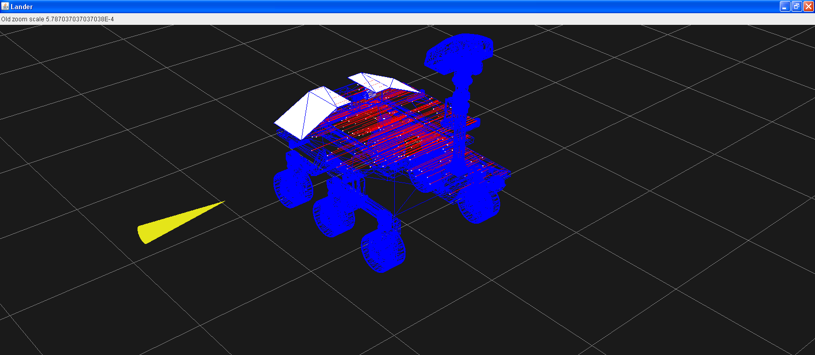
Figure 11 Mars Science Laboratory with particle tracks turned on

xi. Clean Room Specification

Jack B. Berengoltz provided a particle size distribution curve that models the expected densities according to the cleanroom specification in which the surfaces under consideration have been cleaned. For a nominal 100 micron clean room, for example, the distribution defines a density of one 100 micron particle per square meter, and increasingly more at lower diameters, and less at higher diameters.

# CLEANROOM value specifies the cleanliness level of the surfaces. E.g. value=100 signifies 100 micron clean room
CLEANROOM: 100

xii. Particle Size

The Particle Size option allows the user to specify a desired particle radius. The distribution of the desired size particles is based on the Gaussian function shown by Equation 3.12.1.

Equation 3.12.1

Equation 3.12.1 is explained in greater detail in the next section.
When a particle size is entered, the clean room specification provided by the user is overridden. In order to suppress the Particle Size option and only distribute particles based on clean room values, the user can place a “#” in front of the PARTICLESIZE prompt. Refer to the code below for an illustration of the PARTICLESIZE prompt.

# PARTICLESIZE (overrides CLEANROOM) specifies the mean value of the Gaussian used to generate the size of the particles (microns)
PARTICLESIZE: 50

xiii. Sigma Value

The sigma value option allows the user to adjust the amount of particles with his/her desired radius size specified in the previous section. Figure 3.13.1 shows a typical Gaussian curve.

Figure 3.13.1: A sample Gaussian curve; the radius value is 58 with a sigma value of 20

It can be seen from the figure that as the value of sigma, σ, is increased, the probability of particles with the desired radius being created within the simulation will decrease. Refer to the code below for an illustration of the PARTICLESIGMA prompt.

# PARTICLESIGMA specifies the sigma of the Gaussian distribution for the sizes of the particles used (microns)
PARTICLESIGMA: 20

xiv. Particle Number

The Particle Number option coincides with the “Particle Size” and “Sigma Value” prompts. For a non-zero value, the number specified with be the number of particle per square meter that are distributed along the geometric shape. If this option is not used, in other words it is commented out using the “#” symbol, the “Clean Room Specification” option will be. Refer to the code below for an illustration of the PARTICLENUMBER prompt.

# PARTICLENUMBER (if PARTICLESIZE non-zero) specifies number of particles to generate per square meter
PARTICLENUMBER: 500

xv. Surfaces

The Surfaces option allows the user to specify which surfaces(s) of the geometric shape to distribute particles on. Three options exist for this command: “ALL,” “TOP,” and “SIDE.” When “ALL” is chosen, particles will be distributed on all faces of the geometric shape. The “TOP” option will only place particles on the top surfaces of the geometric shape. A “SIDE” response will only distribute particles on the leading faces of the geometric shape. Refer to the code below for an illustration of the SURFACES prompt.

# SURFACES [ALL|TOP|SIDE] indicates which model surfaces are to be sprinkled with particles (this
# specification is ignored if using CLEANROOM particles)
SURFACES: ALL

xvi. Particle Density

The Particle Density option allows the user to specify the density of the microparticles used in the simulation. The units of density used in the Mars Lander Particle Contaminant Simulation Program are kilograms per cubic meter. Refer to the code below for an illustration of the PARTICLEDENSITY prompt. The density displayed in the code below corresponds to that of silica sand.

# PARTICLEDENSITY value specifies the density of the contaminant particles (kg/m^3)
PARTICLEDENSITY: 2600

xvii. Batch Mode

The Batch Mode option allows the user to declare when the simulation should begin running. Two options exist for this command: “ON” and “OFF.” When turned “ON,” the simulation will begin immediately upon opening the program. The simulation will not end until the number of experiments as specified by the user (Refer to Chapter #, Section xiii) is completed or until the user presses the “Stop” button in the GUI. When this option is turned “OFF,” the simulation will only start when the user presses the “Start” button in the GUI. For both options, the user’s preferences will be used from the Configuration File and neither response compromises the validity of the results. However, any changes made in the GUI during the simulation will override those specified in the Configuration File. The experiments will continue to run and for every new experiment, the settings will be reset to correspond to those indicated in the Configuration File. Refer to the code below for an illustration of the BATCH prompt.

# BATCH ON to immediately run simulation and exit when complete
BATCH: ON

xviii. Experiments

The Experiments option allows the user to define his or her desired number of simulations to be performed within the defined atmosphere and parameters. An infinite number of responses exist for this command ranging from “1” in increments of one to any given number. The user is alerted that with an increasing number of experiments, the simulation completion time increases. Likewise, an increased number of experiments creates a more accurate total set of data because the probability of particle placement increases. Refer to the code below for an illustration of the EXPERIMENTS prompt.

# EXPERIMENTS n to run n experiments
EXPERIMENTS: 20

Chapter 4: Starting the Simulation

This chapter contains instructions on how to start the Mars Lander Particle Contaminant Simulation Program.

After installing the necessary programs needed to run the Mars Lander Particle Contaminant Simulation Program, the user is able to run the program. (For complete details on how to install the necessary programs, refer to Chapter #.) Again, the user is reminded that these instructions apply only to systems using Microsoft ® Windows®. However, JAVA® is compatible with Linux®. To begin, the user is advised to make sure that the files contained in the Mars Lander Particle Contaminant Simulation Program folder appear on the “Local Disk (C:)” drive. This drive can be found under “My Computer.”
After the proper location of these files has been confirmed, open a “Command Prompt” window by opening the “Start” menu and going into “All Programs” and then “Accessories.” An image of the “Command Prompt” window can be seen below in Figure 4.1.

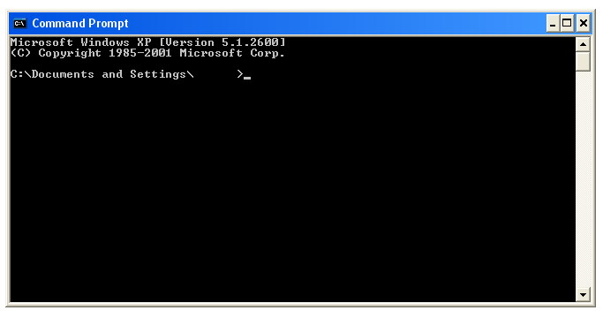
Figure 4.1: Microsoft ® Windows ® “Command Prompt” window

The name of the computer will appear in the blank space after the “Documents and Settings\” text.

The user must then type the following command to access the “Mars Lander” folder. This folder contains the files needed to run the Mars Lander Particle Contaminant Simulation Program. After each command, press the “Enter” button.

cd \marslander

Be aware that a space is present between “cd” and “\”. Next, type the command below.

setup

Note that there are no spaces in this command. Finally type the remaining command to run the Mars Lander Particle Contaminant Simulation Program.

java Lander

Be aware that this code is case-sensitive. If the user wishes to specify the amount of Random Access Memory, or RAM, allotted to the program by the computer, he or she can type an additional option between the words “Java” and “Lander.” The command for this can be seen below.

java –mx512m Lander

For this particular example, the amount of RAM given to the program is 512 megabytes. The final “Command Prompt” window will appear as it does in Figure 4.2.

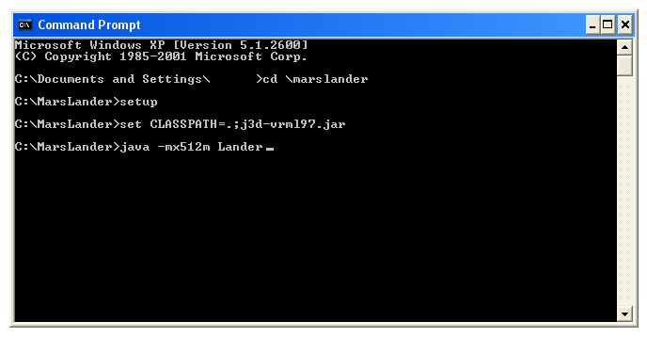
Figure 4.2: “Command Prompt” window containing the commands needed to start the Mars Lander Particle Contaminant Simulation Program

When the “Enter” button is pressed after the final command is written into the “Command Prompt” window, a series of lines will be printed within the window detailing the program process. Depending on several configuration file options, such as the number of particles to be used in the simulation and computer capabilities, the program may take a noticeable amount of time to load. Depending on the specifications made in the configuration file, the command prompt window’s appearance will differ. A sample image of the “Command Prompt” window while program specifications are being printed can be seen in Figure 4.3.

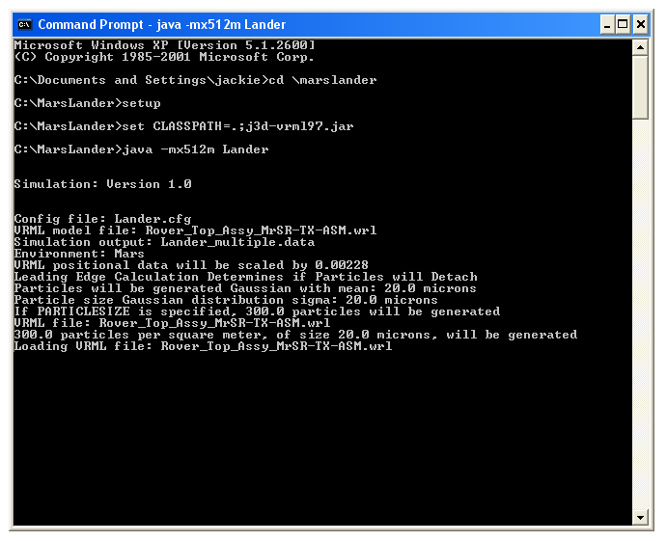
Figure 4.3: Image of the “Command Prompt” window while the Mars Lander Particle Contaminant Simulation Program is being loaded

It can be seen in Figure 4.3 that several preferences specified in the configuration file appear in the “Command Prompt” window such as the atmosphere, scale to applied to VRML file dimensions, and number of particles to be used in the simulation. After these specifications are displayed, the “Command Window” will then print a series of functions as described in Appendix #. The user is cautioned that warnings may appear in the “Command Prompt” window. If the warnings are not ignored by the program, they may be linked to improper inputs in the “Command Prompt” window. In this case, the user is advised to check his or her entries.
Following the printout, the Mars Lander Particle Contaminant Simulation Program will begin and the simulation window will appear on the screen. For more information on the simulation window and graphical user interface, refer to Chapter 5.
Chapter 5: Graphical User Interface (GUI)

Below is a list of the descriptions included in this chapter:

- Description of the buttons
  - Top View
  - Side View
  - Zoom In/Out
  - Left
  - Right
  - New
  - Start/Stop
  - Hide Lander
  - Save view as JPG
  - Write Data File
- Description of the check boxes
  - Debug
  - Show Particle Motion
  - Show Tracks
  - Save Image Every Step
- Description of the Sliders
  - Wind Speed
  - Wind Direction

Graphical user interfaces, hereinafter referred to as GUI, are designed to create communication between a program and its user. Specifically for the Mars Lander Particle Contaminant Simulation Program, the GUI, as seen in Figure 5.1, allows the user to make several decisions regarding the appearance and performance of the simulation. Many options that appear in the GUI do not appear in the configuration file and vice versa. The user should be aware that the simulation window and GUI are two different windows but work together.

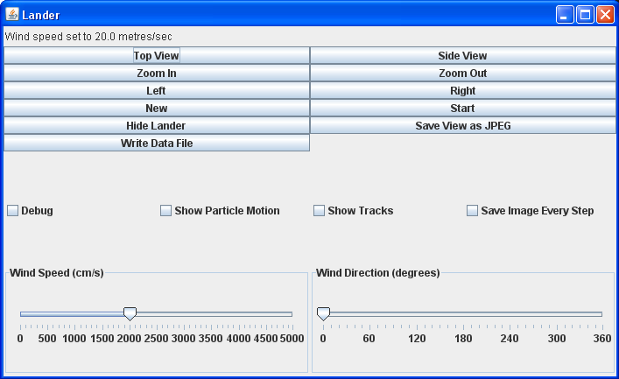
Figure 5.1: Graphical User Interface

The options are described below in the following sections.

i. Buttons

Refer to Figure 5.i.1 for an image of the GUI buttons.

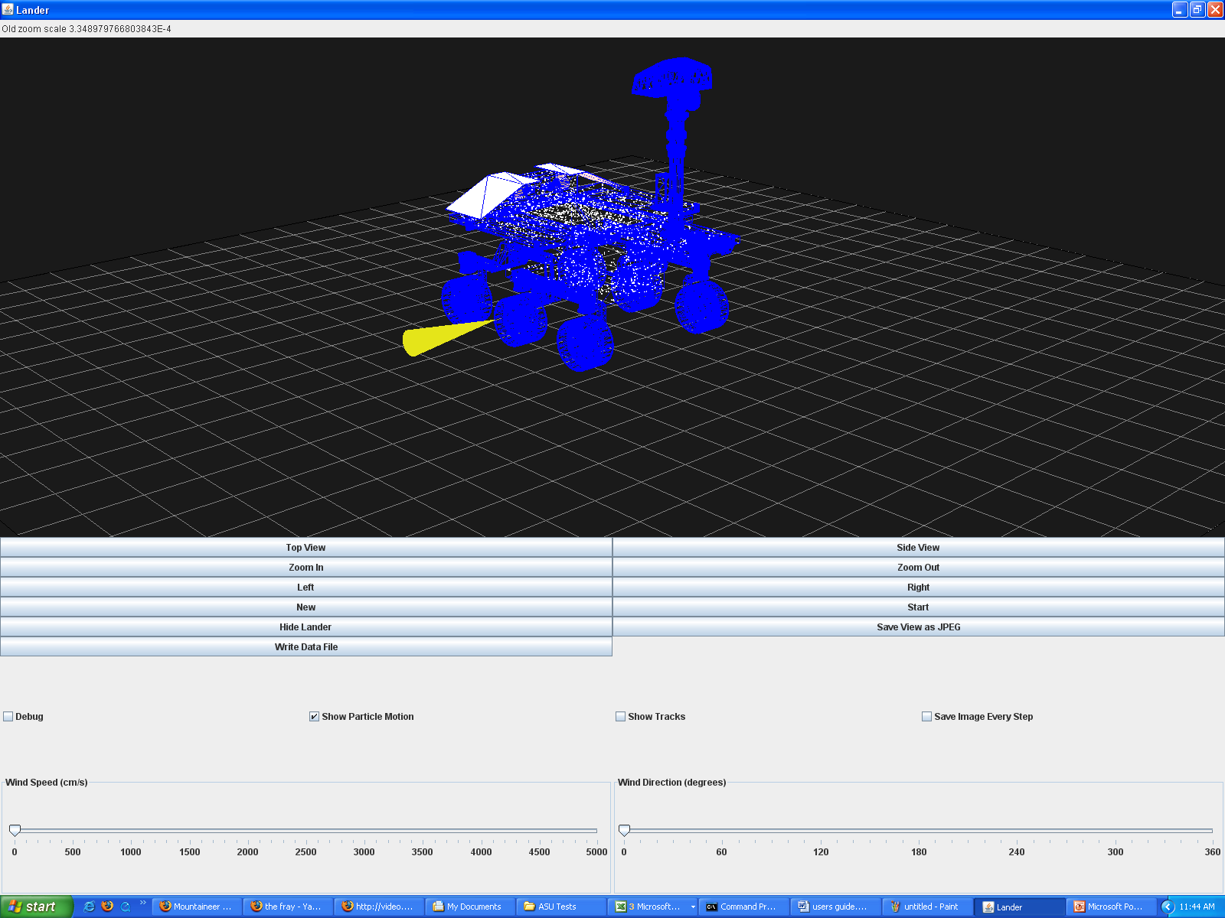
i
d
k
c
a
b
f
h
g
j
e
Figure 5.i.1: GUI buttons

A complete list of the corresponding descriptions can be found below.

a. Top View

When clicked, the “Top View” button adjusts the viewing screen to allow the user to see the geometric shape from above. Refer to Figure 5.i.a.1.

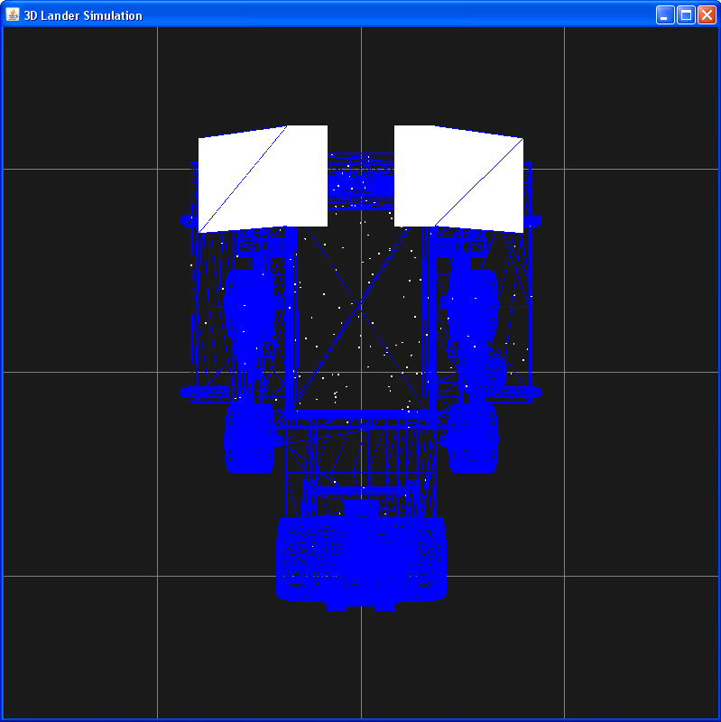
Figure 5.i.a.1: Top view of the Mars Science Laboratory in the Mars Lander Particle Contaminant Simulation Program

b. Side View

The “Side View” button adjusts the viewing screen to allow the viewer to see the geometric shape from the side. Refer to Figure 5.i.b.1.

Figure 5.i.b.1: Side view of the Mars Science Laboratory in the Mars Lander Particle Contaminant Simulation Program

c. Zoom In

The “Zoom In” button allows the viewer to magnify the contents in the viewing screen. This operation does not affect the simulation in progress.

d. Zoom Out

The “Zoom Out” button allows the viewer to minimize the contents in the viewing screen. This operation does not affect the simulation in progress.

e. New

When clicked, the “New” button rids the viewing window of all particles used in the previous experiment. Likewise, the wind vector is reset to correspond with the wind vector specified in the configuration file. The particles are placed on the geometric shape and the program is ready for a new simulation to being. The view position of the geometric shape is not reset. Refer to Figure 5.i.e.1 for an image of the simulation screen after the “New” button is pressed.

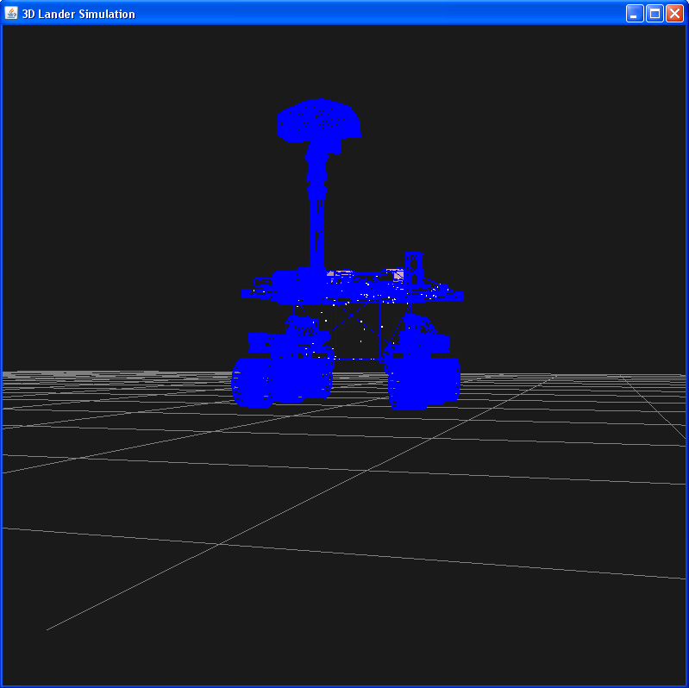
Figure 5.i.e.1: View of the simulation screen after clicking the “New” button

f. Start/Stop

The “Start/Stop” button allows the user to begin, pause, or end the simulation at any time even when the “Batch Mode” is turned on (Refer to Chapter 3, Section xvii for a complete description of the “Batch Mode”). When stopped, the simulation can be restarted by simply pressing the “Start” button. In this case, the simulation will continue from where it stopped. Only when the “New” button is pressed will the simulation reset (Refer to Section 1.e in this chapter for a complete description of the “New” button).

g. Hide Lander/Show Lander

The “Hide Lander/Show Lander” button allows the user to remove the geometric shape from the viewing window and display only the particles and wind vector. This option is especially useful when the user wants to see the distribution of the particles on the geometric surface. Refer to Figures 5.i.g.1 and 5.1.g.2 for an image of the viewing screen in the absence of the geometric shape.

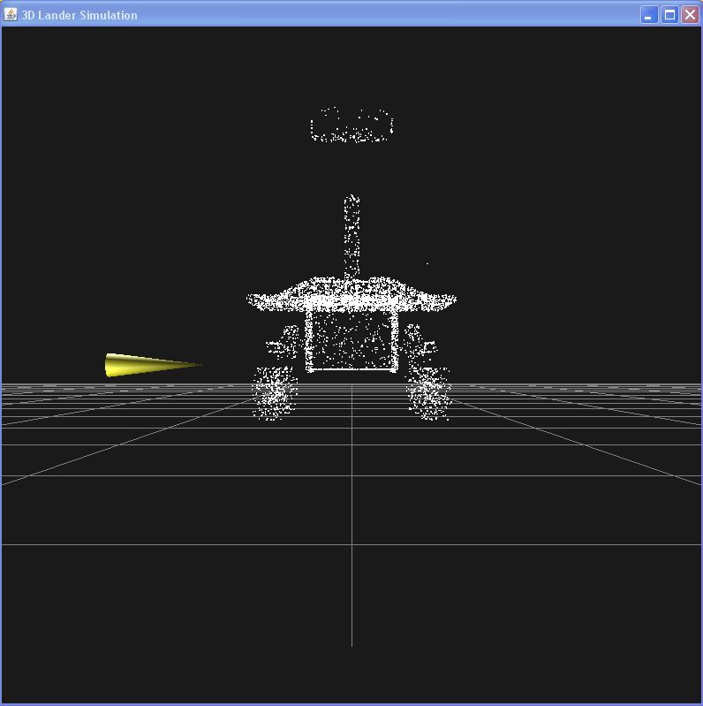
Figure 5.i.g.1: Front view of only the particles on the Mars Science Laboratory

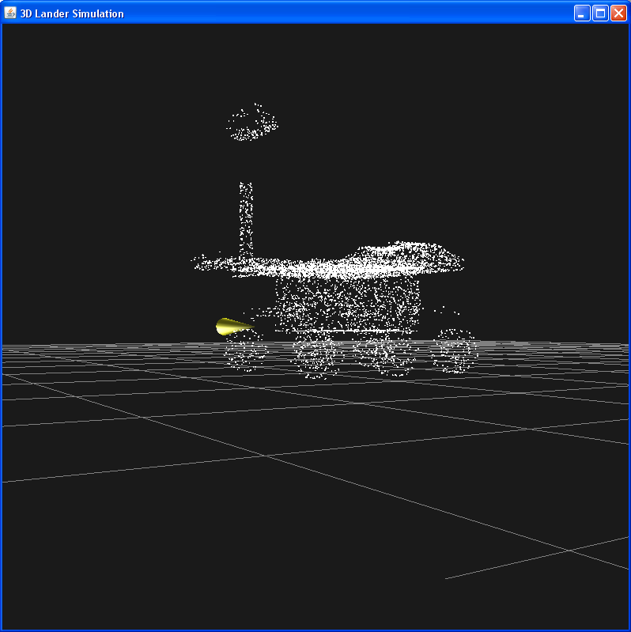
Figure 5.i.g.2: Additional view of only the particles on the Mars Science Laboratory

h. Save View as JPEG

An image of the viewing screen can be saved by clicking the “Save View as JPEG” button. The image, titled “Lander.jpg,” will be placed in the “Mars Lander” directory created in Chapter 2, Section iii. This feature is also discussed in Chapter 6, Section i.

i. Write Data File

A data file of the progress and information for the experiment can be written at any time during the simulation by clicking the “Write Data File” button. The file, titled “Lander_multiple.data” as specified by the user in the configuration file, will be placed in the “Mars Lander” directory created in Chapter 2, Section iii. This feature is also discussed in Chapter 6, Section iii.

ii. Check Boxes

Each check box option appears in the configuration file as well as in the GUI (Refer to Chapter 3 for a complete description of the configuration File). Any choices made in the GUI will override the user’s responses in the configuration file. However, when the “Batch” mode is turned “ON,” as described in Chapter 3, Section xvii, the settings will reset to satisfy the specifications made in the configuration file. Refer to Figure 5.ii.1 for an image of the check boxes contained in the GUI.

c
b
a
d
Figure 5.ii.1: GUI check boxes

A complete list of the corresponding descriptions can be found below.

a. Debug

When the “Debug” box is checked, the details of the simulation while it is running, including area calculations as well as information for every particle and wind vector, will be printed in the Command Prompt Window. Refer to Chapter 3, Section iii for a complete description of the Debug option.

b. Show Particle Motion

When the “Show Particle Motion” box is checked, the motion of the particles as they detach from the geometric surface and fall to the planet’s surface will be displayed. Refer to Chapter 3, Section vi for a complete description of the Particle Motion option.

c. Show Tracks

When the “Show Tracks” box is checked, the path of each particle will be shown as it moves along the surface of the geometric shape. Refer to Chapter 3, Section x for a more detailed description of the Particle Tracks option.

d. Show Image Every Step

When the “Show Image Every Step” box is checked, and image of the simulation window is captured and saved each time something changes in the screen throughout the simulation. This gives the user the option of creating a movie of the experiment. This feature is also discussed in Chapter 6, Section ii.
iii. Sliders

Two sliders are present at the bottom of the GUI; one controls the wind speed while the other controls the direction. Wind vector specification options appear in the Configuration File as well and are implemented when the “Batch Mode” is turned on (Refer to Chapter 3 for a complete description of the Configuration File and Batch Mode). Any choices made in the GUI will override the user’s responses in the Configuration File. Refer to Figure 5.iii.1 for an image of the check boxes.

b
a
Figure 5.iii.1

A complete list of the corresponding descriptions can be found below.

a. Wind Speed

The “Wind Speed” slider allows the user to change the speed of the wind in centimeters per second. The range for this slider is 0 to 5000 cm/s.

b. Wind Direction

The “Wind Direction” allows the user to change the direction of the wind. The vector can be rotated a full 360 degrees about the z-axis.

iv. Simulation

After the user feels comfortable with the options and features in the Mars Lander Particle Contaminant Simulation Program, he or she can begin an experiment. While the simulation is running, details on the program’s process will be printed in the “Command Prompt” window. Also, an update on the status of the particles will also be displayed in the top left corner of the GUI. Refer to Figure 5.iv.1.

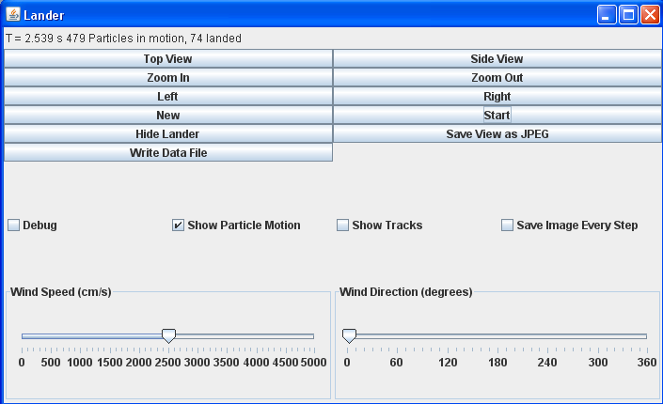
Figure 5.iv.1:

Figure 5.iv.1 shows the GUI window of an experiment. The status of the particles can be seen in the top left corner; out of 696 particles in the experiment (found in the program’s command prompt window), 479 particles are in motion and 74 have landed on the planet’s surface.

The information in the top left corner of the simulation window is updated every fraction of a second in the program’s timescale.

Chapter 6: Data Analysis

The Mars Lander Particle Contaminant Simulation Program provides plenty of useful data regarding particle contamination for each simulation. With the capability of creating pictures, movies, and data files, this program can be used to predict and understand the behavior of microparticles in any given atmospheric conditions.
Instructions are included in this chapter for creating the following data analysis aids:

- Pictures
- Movies
- Data File

i. Pictures

As discussed in Chapter 5, Section i.h, a snapshot can be taken of the simulation window. In order to retrieve this image, the user should go to the “Mars Lander” folder and find the JPG file titled “Lander.jpg.” This image title will also contain a number to distinguish it from previous and future snapshots.

ii. Movies

iii. Data File

As described in Chapter 5, Section i.i, the Mars Lander Particle Contaminant Simulation Program is capable of writing an output file with data on each particle. Specifically, the data file indicates whether or not a particle has detached from the geometric surface and if it has landed on the planet’s surface. Table 6.iii.1 shows an excerpt from a typical data file.

Table 6.iii.1: Excerpt from a typical data file
Code | X | Y | Z | Radius | X_{free} | Y_{free} | Z_{free}
1 | 256.4606 | 556.1624 | 38.24902 | 4.48E-06 | 0 | 0 | 0
1 | 262.7832 | 542.0361 | 38.24902 | 1.44E-05 | 0 | 0 | 0
2 | 13905.73 | 88096.79 | 576.1983 | 2.76E-05 | -95.7398 | -305.027 | 849.4143
2 | 14781.86 | 93646.26 | 712.61 | 1.96E-05 | -98.565 | -305.027 | 849.4143
2 | 5993.602 | 37715.79 | -0.81918 | 2.81E-05 | 92.94045 | 460.478 | 282.404
1 | 186.9345 | 319.6781 | 282.404 | 1.67E-05 | 0 | 0 | 0
2 | 4451.144 | 28472.81 | -180.669 | 3.60E-05 | 14.42606 | 460.478 | 282.404
1 | -184.661 | -47.819 | 282.404 | 1.78E-05 | 0 | 0 | 0
1 | -184.761 | 436.5353 | 282.404 | 1.53E-05 | 0 | 0 | 0
1 | 184.7369 | -23.9373 | 282.404 | 1.04E-05 | 0 | 0 | 0
3 | 3677.12 | 23440.52 | -212.816 | 3.70E-05 | -83.5213 | -303.232 | 254.667
1 | -71.3801 | -329.678 | 254.667 | 1.93E-05 | 0 | 0 | 0
3 | 3274.975 | 20729.67 | -212.811 | 3.94E-05 | -56.3098 | -303.232 | 254.667
1 | -72.1653 | -316.769 | 254.667 | 4.07E-06 | 0 | 0 | 0
3 | 4944.141 | 32197.4 | -212.793 | 4.15E-05 | -78.9 | 483.1626 | 397.353
3 | 2041.128 | 14766.02 | -212.802 | 3.07E-05 | -301.815 | -26.7424 | 90.14201
1 | -306.829 | -139.446 | 90.14201 | 1.00E-06 | 0 | 0 | 0
1 | 13.88302 | -451.922 | 320.075 | 3.28E-06 | 0 | 0 | 0
2 | 6994.557 | 43803.98 | 104.626 | 2.45E-05 | -13.9749 | -446.151 | 320.075
2 | 7487.936 | 46898.33 | 168.9246 | 2.06E-05 | -10.6932 | -446.151 | 320.075
2 | 5519.393 | 34308.06 | -86.1805 | 3.37E-05 | 14.86756 | -446.151 | 320.075
1 | -176.29 | 344.551 | -20.108 | 3.89E-06 | 0 | 0 | 0

As discussed in Appendix #, Section #, the particles are classified by a code number. The number 1 indicates that the particle has not detached from the geometric surface; the number 2 indicates that the particle has detached from the geometric surface and it currently in free-flight; the number 3 indicates that the particle has detached from the geometric surface and has landed on the planet’s surface.
The x, y, and z coordinates in the data file describe the position of each particle at the time the data file was written. It can be seen that each particle is described by a system of three-dimensional coordinates regardless of whether or not it has detached from the geometric surface. The coordinate units are meters.
The radius column in the data file provides the radius of each particle in meters.
The x_{free}, y_{free}, and z_{free} coordinates describe the position of each particle when it detached from the geometric surface. The x_{free}, y_{free}, and z_{free} coordinates of code 1 particles will always be (0,0,0) as they have not detached from the surface.

In order to create plots with the given data, it suggested that the user imports the data into a Microsoft Excel® spreadsheet. This can be completed by simply copying the data in the output file and copying it into a Microsoft Excel® spreadsheet.

In order to plot a top view of the particles that have landed on the planet’s surface, highlight all columns and rows of the data. Open the “Data” tab in the upper toolbar and then click on the “Sort” option. A view of the Microsoft Excel® window after the sort option has been chosen can be seen in Figure 6.iii.1.

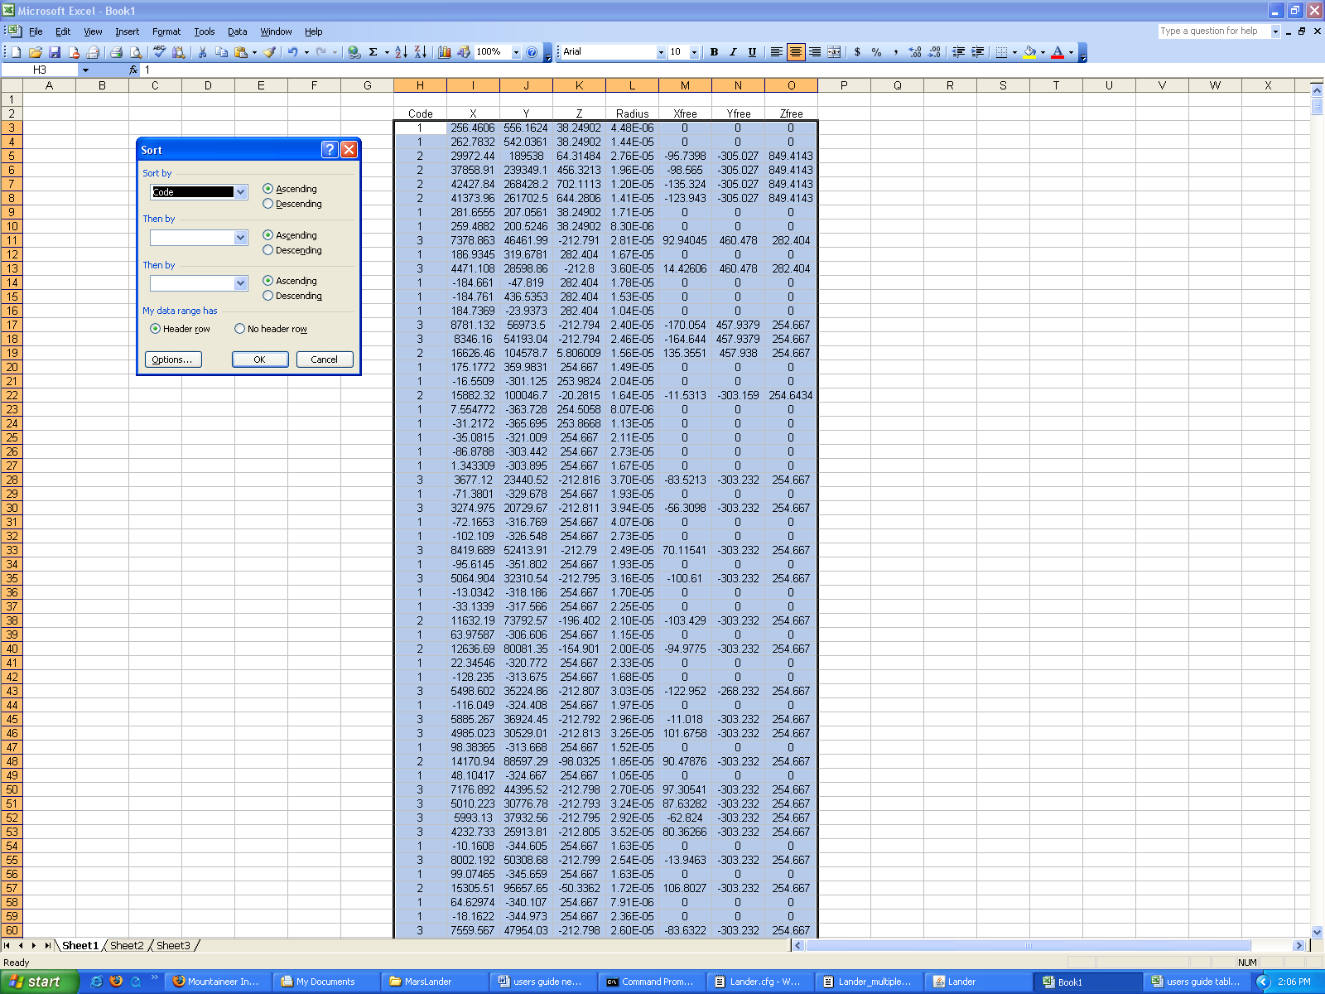
Figure 6.iii.1: Data selection to be sorted

It can be seen that all of the data has been highlighted. Figure 6.iii.2 shows the “Sort” window and the appropriate selections to be made.

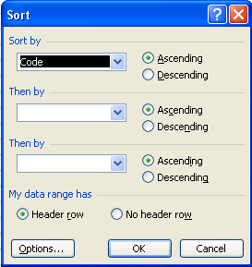
Figure 6.iii.2: Sort data feature

As seen in Figure 6.iii.2, the data should be sorted according to the code, or characteristic, number of each particle. By sorting the characteristic number in ascending order, the code 1 particles will be shown first, then code 2, and finally code 3.
To plot the landed particles, highlight the x and y coordinates of the code 3 particles. In the “Insert” tab on the top toolbar, select the “Chart” option. After the “Chart” option has be chosen, the screen should appear as it does in Figure 6.iii.3.

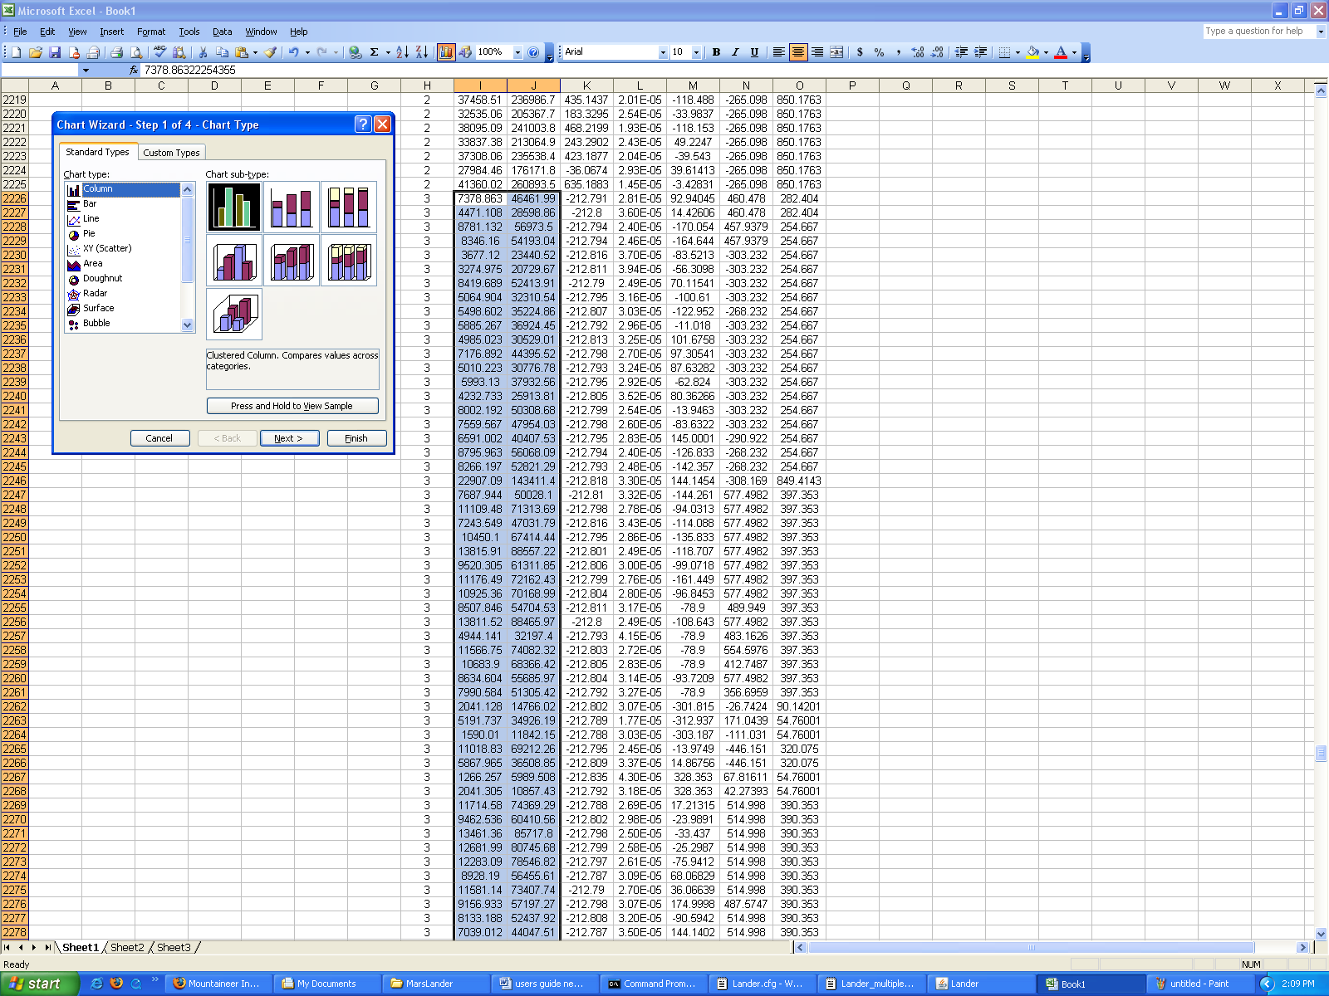
Figure 6.iii.3: Data selection to be graphed

Select the “(XY) Scatter” chart in the “Chart Type” menu under the “Standard Chart” tab. The “Chart sub-type” menu will then appear and the “Scatter” option should be chosen as seen in Figure6.iii.4.

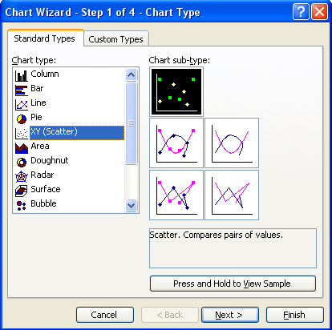
Figure 6.iii.4: Scatter plot feature

Click the “Next” button. The new window will display “Data Range” and “Series” Options as seen in Figure 6.iii.5.

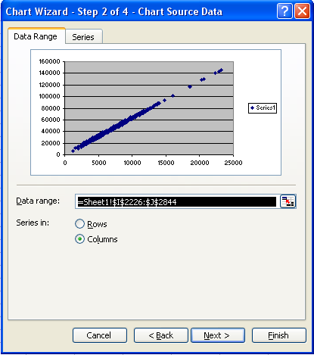
Figure 6.iii.5: Data range specification

The “Data Range” option under the “Data Range” tab describes the values previously highlighted by the user. These values are the x and y coordinates of the landed particles. By choosing the “columns” option in the “Series in” prompt, the user declares that the x and y coordinates should be created in Microsoft Excel® by pairing the neighboring columns. The “Series” tab is shown in Figure 6.iii.6.

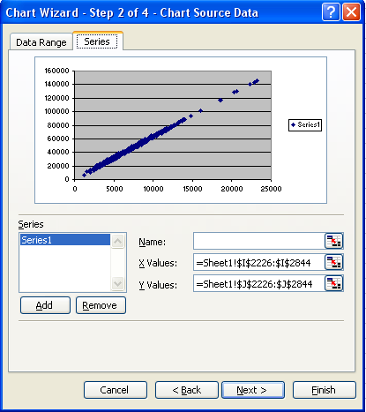
Figure 6.iii.6: Data series specification

The “Series” tab allows the user to specify the values that should be used to create the points on the scatter plot. This is also declared in the “Data Range” tab but can be verified under this tab. A name can be given to each series that is plotted and the x and y values can also be specified. Additional series can be plotted by clicking the “Add” button.
Click the “Next” button.

The next window provides several options for the user to make detailed changes and/or additions to the graph.

Under the “Titles” tab, as seen in Figure 6.iii.7, the user can give the graph a title and label the x and y coordinates.

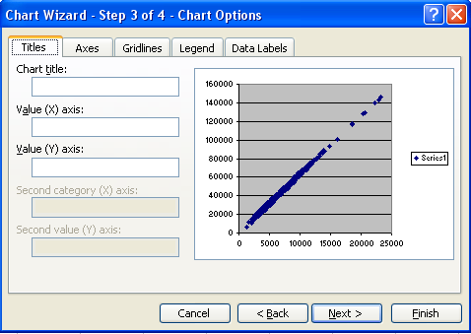
Figure 6.iii.7: Titles Tab

Under the “Axes” tab, the user can display or hide the numbering on the x and/or y coordinate(s). A view of this tab can be seen in Figure 6.iii.8.

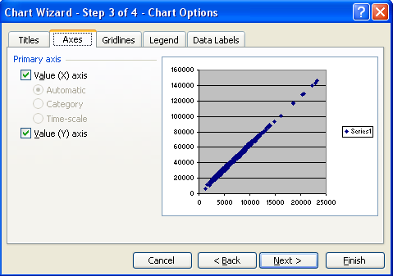
Figure 6.iii.8: Axes Tab

The options under the “Gridlines” tab the user can graph gridlines on the chart. This tab is shown in Figure 6.iii.9. Major gridlines are less precise than minor gridlines. However, the chart tends to appear cluttered when minor gridlines are graphed.

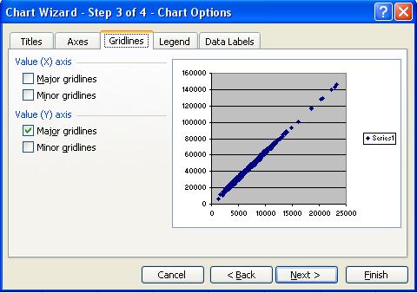
Figure 6.iii.9: Gridlines Tab

The “Legend” tab lets the user position the legend within the graph. The legend can also be hidden if the “Show legend” button is unchecked. This can be seen in Figure6.iii.10.

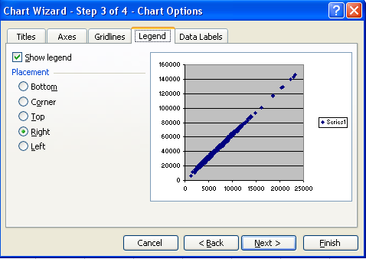
Figure 6.iii.10: Legend Tab

The “Data Labels” tab provides options for labeling the data points on the graph. While the series name and x and y coordinates of each point can be displayed on the graph, this often clutters the graph when many points are plotted. This tab is shown in Figure 6.iii.11.

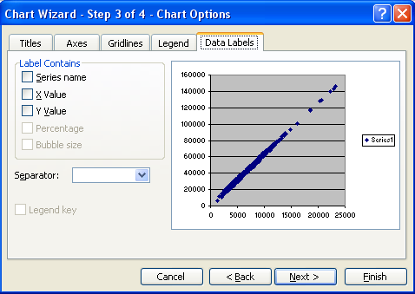
Figure 6.iii.11: Data Labels Tab

The complete graph can be seen below in Figure 6.iii.12.

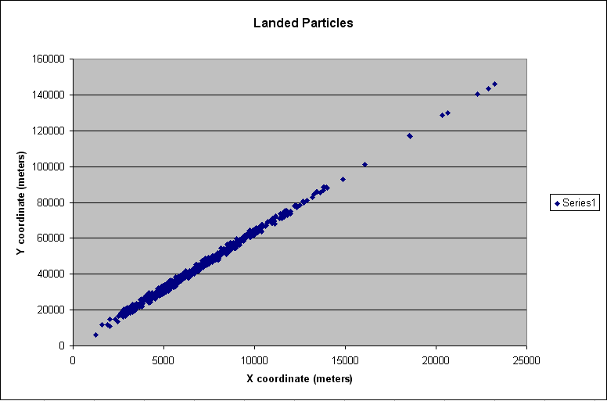
Figure 6.iii.11: Graph of landed particles under constant wind of 40 m/s at 80 degrees from the vertical; geometric shape is the Mars Science Laboratory

More graph samples can be seen below in Figure 6.iii.12 through Figure 6.iii.#.

Figures 6.iii.12 and 6.iii.13 correspond to a simulation of particles resting only on the top face of a box. The wind vector in this simulation remained constant. Figure 6.iii.12 shows the simulation window and Figure 6.iii.13 shows the aerial view of the particles after landing on the planet’s surface.

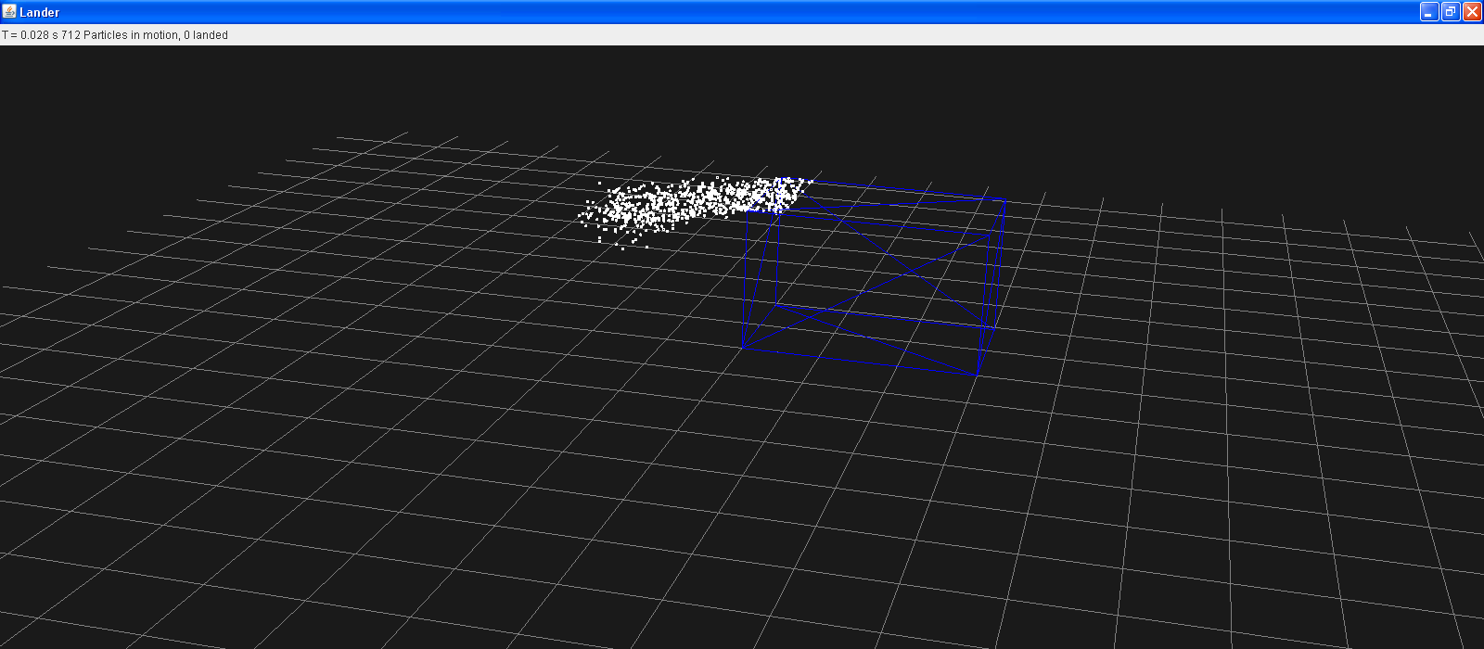
Figure 6.iii.12: Simulation of particles resting on the top surface of a box; data corresponding to this simulation can be seen in Figure 6.iii.13

Figure 6.iii.13: Graph of landed particles under constant winds; geometric shape is a box; the x and y axis have been moved to outline the dimensions of the box so the box does not appear in the graph, only the planet’s surface in front of the box; particles rest on top of the box as seen in Figure 6.iii.12

Figures 6.iii.14 and 6.iii.15 correspond to a box in uniform wind flow with particles placed on every face. Figure 6.iii.14 shows the simulation window and Figure 6.iii.15 shows the aerial view of the particles after landing on the planet’s surface.

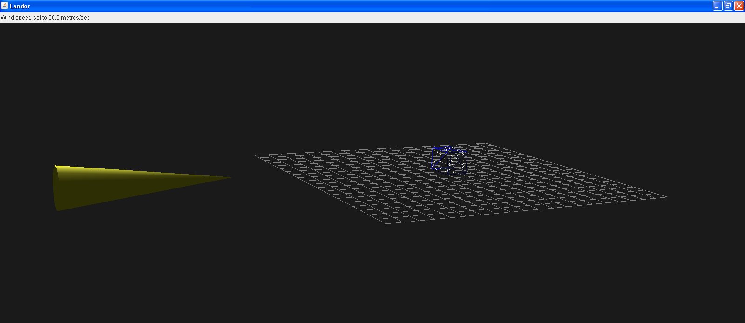
Figure 6.iii.14: Box in uniform wind flow of 50 m/s; particle size is of uniform 200 micron diameter; particle density is 2600 kg/m³; particles are distributed on every face of the box; particle are dislodged and carried downstream; data corresponding to this simulation can be seen in Figure 6.iii.15

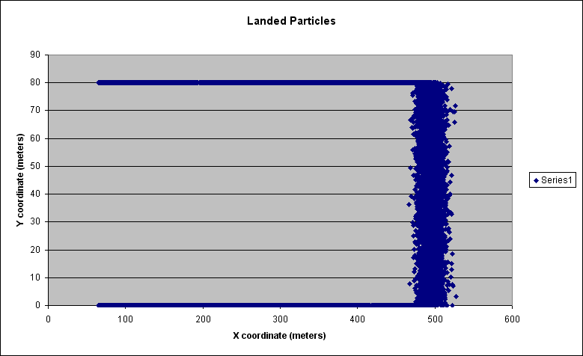
Figure 6.iii.15: Graph of landed particles under constant winds; geometric shape is a box; particles rest on all faces of the box as seen in Figure 6.iii.14

Figures 6.iii.16 and 6.iii.17 correspond to a box in uniform wind flow at 30 degrees from the x-axis with particles placed on all sides. Figure 6.iii.16 shows the simulation window and Figure 6.iii.17 shows the aerial view of the particles after landing on the planet’s surface. The particle behavior follows that outlined in Chapter 3, Section ix regarding wind vectors that make an angle less than 45 degrees with the inward normal on the faces of the geometric surface.

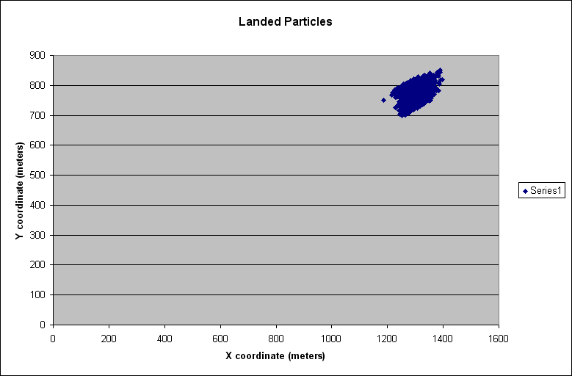

Figures 6.iii.18 and 6.iii.19 correspond to a box in uniform wind flow at 60 degrees from the x-axis with particles placed on all sides. Figure 6.iii.18 shows the simulation window and Figure 6.iii.19 shows the aerial view of the particles after landing on the planet’s surface. The particle behavior follows that outlined in Chapter 3, Section ix regarding wind vectors that make an angle greater than 45 degrees with the inward normal on the faces of the geometric surface.

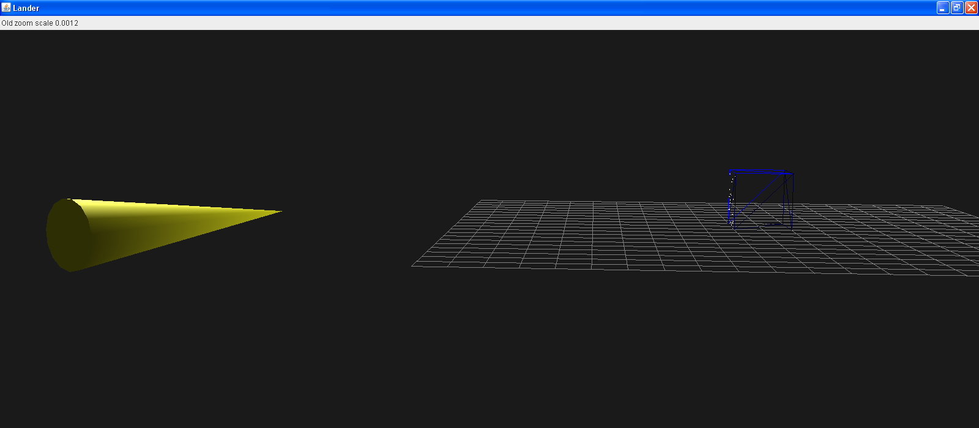
Figure 6.iii.18: Box in uniform wind flow of 50 m/s at 60º from the x-axis; particle size is of uniform 200 micron diameter; particle density is 2600 kg/m³; particles are distributed on every face of the box

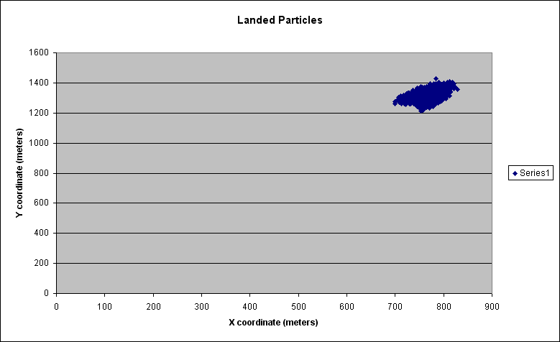Figure 6.iii.19: Graph of landed particles under constant winds; geometric shape is a box; particles rest on all faces as seen in Figure 6.iii.18

Figures 6.iii.20 and 6.iii.21 correspond to a box in uniform wind flow with particles placed on only the leading face. Figure 6.iii.20 shows the simulation window and Figure 6.iii.21 shows the aerial view of the particles after landing on the planet’s surface.

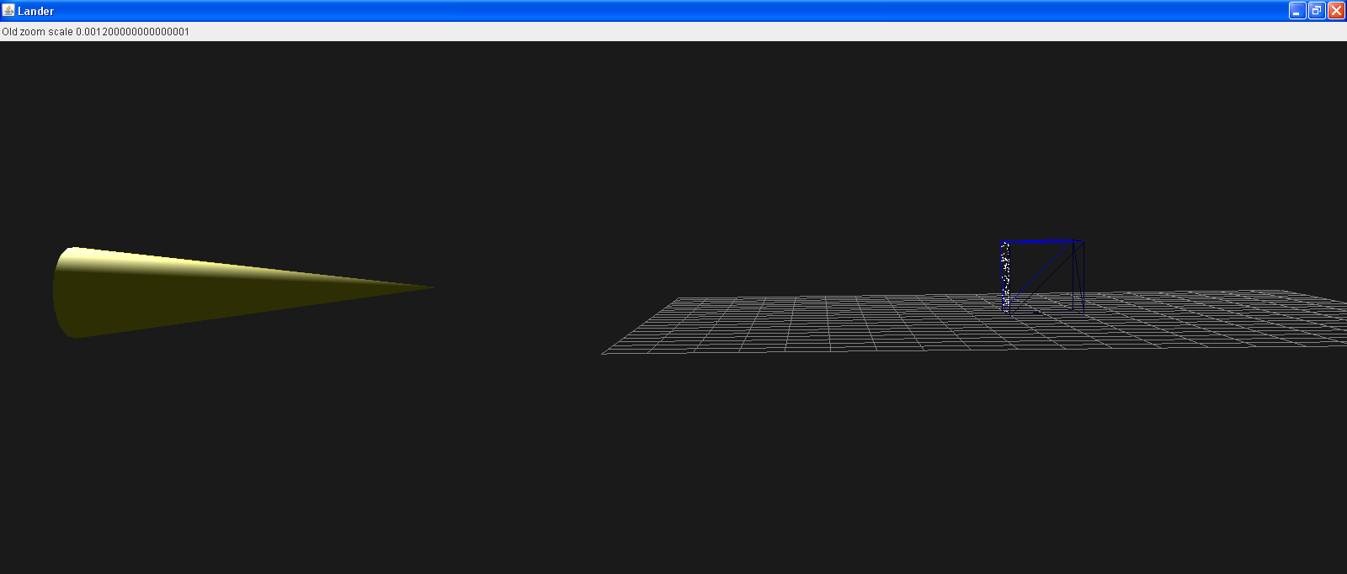
Figure 6.iii.20: Box in uniform wind flow of 50 m/s normal to leading face; particle size is of uniform 200 micron diameter; particle density is 2600 kg/m³; particles are only distributed on leading face; particles remain stationary

INSERT GRAPH
Figure 6.iii.21: Graph of landed particles under constant winds; geometric shape is a box; particles rest only on leading face as seen in Figure 6.iii.20

Box lander flow normal to face and at an inclination greater than 45 deg:

Figures 6.iii.22 and 6.iii.23 correspond to a box in uniform wind flow with particles placed on only the leading face. Figure 6.iii.22 shows the simulation window and Figure 6.iii.23 shows the aerial view of the particles after landing on the planet’s surface.

Complete lander uniform particles:

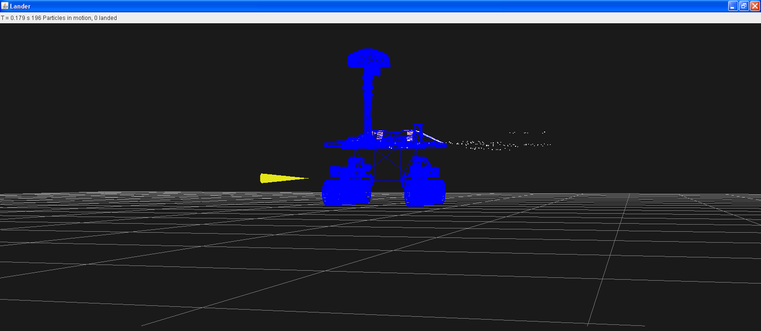
Figure 6.iii.#: Mars Science Laboratory in uniform wind flow of 25 m/s; particle size is of uniform 100 micron diameter; particle density is 2600 kg/m³; data corresponding to this simulation can be seen in Figure 6.iii.#

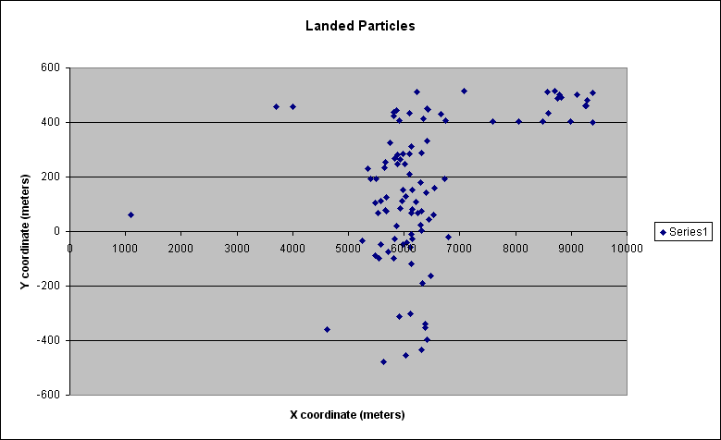
Figure 6.iii.#: Graph of landed particles under constant winds; geometric shape is the Mars Science Laboratory; particles rest on all sides of the lander as seen in Figure 6.iii.#

Complete lander with uniform particles and a wind profile:

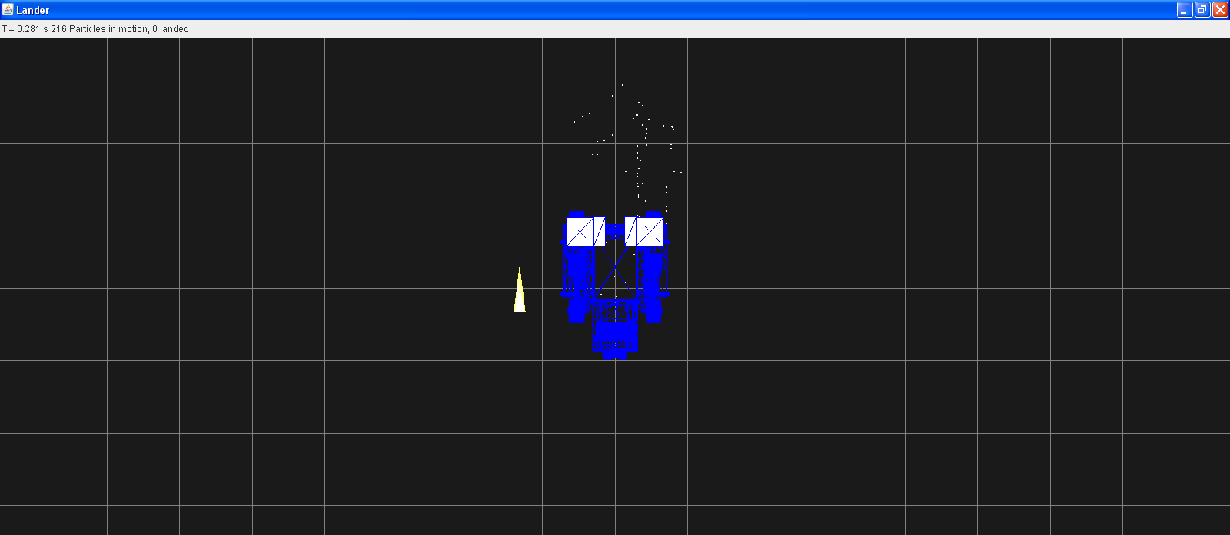
Figure 6.iii.#: Mars Science Laboratory in varying wind flow of constant velocity of 20 m/s; wind directions changes in increments of 15º every 0.01 seconds ranging from 0 º to 90 º from the vertical; particle size is of uniform 100 micron diameter; particle density is 2600 kg/m³; data corresponding to this simulation can be seen in Figure 6.iii.#

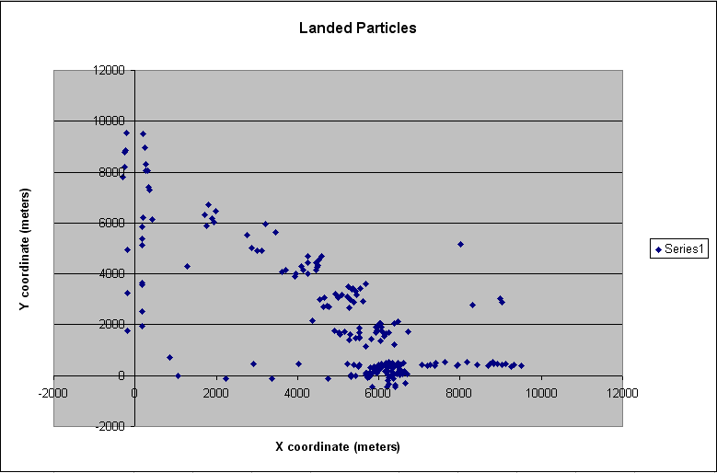

Variable sizes and variable winds:
FIGURE
Figure 6.iii.#: Mars Science Laboratory in varying wind flow of constant velocity of 20 m/s; wind directions changes in increments of 15º every 0.01 seconds ranging from 0 º to 90 º from the vertical; particle size is of varying diameter with desired diameter of 100 microns and a sigma value of 20; particle density is 2600 kg/m³; data corresponding to this simulation can be seen in Figure 6.iii.#

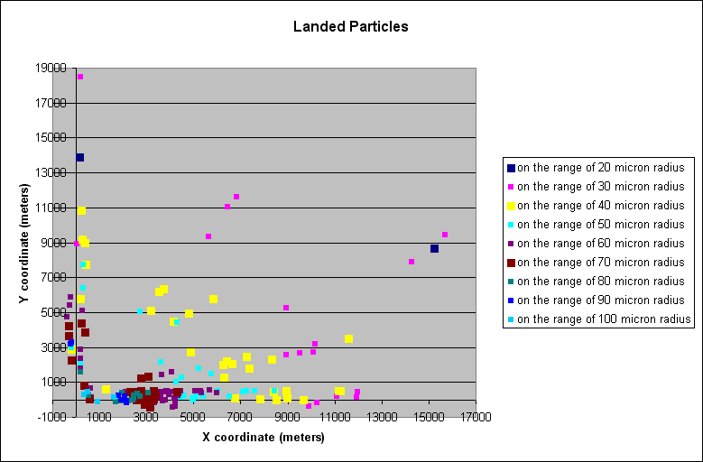

============

Appendix #: Contamination Transport and Flow

The Mars Lander Particle Contaminant Simulation Program is capable of simulating several types of flow around bodies in order to demonstrate the probability of particle detachment. The following sections describe several types of flow modeled in the program.

i. Title

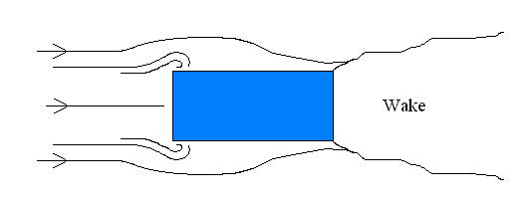
Figure 12 Wind profile around a bluff body

The Figure shows the wind profile around a bluff body. It can be seen that as the wind approaches the front of the body it stagnates at the center and flows around the corners creating small vertices. As the flow continues to pass over the top and bottom faces of the body, small regions of dead air are formed due to slight flow detachment. Separation at the end of the body creates a wake behind it.

Flow over a bluff body:
We describe the general characteristics as an aid to modeling. Consider the symmetric flow over a cube in the plan view. The side view looks very similar.

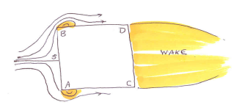

Particles move along SA and SB and separate at the edges A and B. The sketch shows small leading edge bubbles at A and B and reattached flows along AC and BD where particles are subject to wall shear stress. The unsymmetric case is shown below.

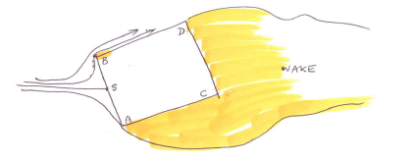

In the unsymmetric case, we have the situation shown above where we have a leading edge bubble on one face and a separated flow in the other. Particles in the stagnation face feel the wind. Here the velocity increases radially from zero to the free stream velocity at the corner. Particles roll along the surface if the velocity is sufficient to dislodge them and become free at the edge. Particles on surfaces touching the shaded regions (dead air regions) do not move. In this case the flow is attached on BD (except at the bubble) and separated along AC.

The side view is similar. Except for the front, flow is separated. Thin objects such as solar panels have attached wind flows if oriented at zero angle of attack. Then the particles on both surfaces feel the wind. In an unsymmetrical case one surface will be in dead air.

The stagnation point occurs on the face whose inward surface normal makes an angle less than 45 degrees to the wind direction. Particles on this face are subjected to a shear stress and will move when the stress is large enough. If the angle of wind is increased beyond 45 degrees, the stagnation point shifts to another face as shown below where BD is the stagnation face instead of AB.

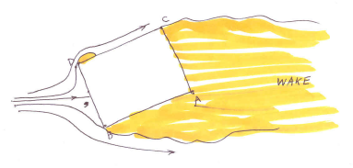
A sketch in side view including a solar panel is shown below. The rover is shown at a negative angle of attack. Dots on surfaces where particles can move are also shown.

Rules for determining stagnation points and flow regions:

This scheme is followed to define the flow. Find the angle between the wind vector and the inward normal of a face. If the angle is less than 45 deg, this face has a stagnation point. There is only one such point. If the angle is between 45 deg and 90 deg, this face has attached flow with velocity equal to the free stream velocity parallel to the surface. If the angle is greater than 90 deg, the face has detached flow. Particles can detach only in the first two cases, of stagnation laminar flow and of turbulent attached flow.

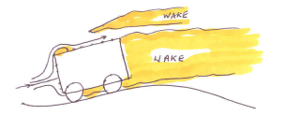

Particle detachment:

Boundary layers are from mm to cm thick on the sides and on the order of a cm on the stagnation face. The thicker the boundary layer the smaller the shear stress and smaller the number of particles dislodged. C_{f} is the skin friction coefficient defined by wall shear stress divided by ½ ρ U² . On the rover body we determine the velocity vector which is (1) the same as the free stream if the flow is attached(glancing flow), (2) zero if not attached and (3) increasing from zero to magnitude U on the face with a stagnation point. This velocity is not directly felt by particles which sit on the walls covered by a boundary layer which shields them from the outside flow. The velocity at the wall is zero and it increases from zero to the value outside the thin boundary layer. The force acting on particles is related to wall friction stress which is τ = C_{f} ½ ρ U². This determines the fraction of particles that are detached at the size that are detached at this value of shear stress. The particle detachment function is applied to all cases of flow (1), (2 ) and (3) above except that in case 2 there is no flow. Particles that roll as indicated refer to the fraction of particles dislodged at a wind of magnitude U for the size of particles being considered. If the particles are very small the wall shear stress will be insufficient to dislodge them and they will stay put.
Skin friction in stagnation point flow:

The stagnation face is simpler than other faces because the boundary layer is of constant thickness and wall shear stress has a simpler expression with no dependence on distance x downstream of a leading edge. The boundary layer thickness is constant here and is

with L indicating the distance from the stagnation point to the edge. There is no singularity at x = 0. The wall friction is
.
Using the equation for the radial velocity
, we get

which increases linearly with x. The Reynolds number based on δ is
and has the value = 150 under Martian conditions and is likely to be laminar. Flow on the sides after negotiating leading edge bubbles will be turbulent. Therefore, in the model laminar flow is assumed over the stagnation face and turbulent boundary flows elsewhere.

Skin friction in flat plate flow:

On the sides the turbulent skin friction coefficient is given by
,
based on the x Reynolds number
,
and the wall shear stress by
with the arrow signifying a column vector at all particle positions.
Appendix #: Functions

For a copy of the complete code used to create and run the Mars Lander Particle Contaminant Simulation Program, the user is directed to the “Lander.java” file provided.

i. Class Lander

The Lander Class consists of various declarations used to setup the simulation. The default Earth and Mars environments are assigned their respective atmospheric properties including air density and viscosity, and gravity. The level of accuracy for each output result is set and is specific to the data type. Likewise, variables for various particle sizes are declared using the “double” command.
This class also declares that the simulation will run in a three-dimensional plane with a three-dimensional geometric figure. Likewise, the default configuration options are set with the possibility of being overwritten by the user’s configuration file. The “Batch” mode is also setup here allowing the user to immediately being running experiments by using the configuration file.

a. public Lander(String[] args)

Under this method, the configuration file is read, and the default settings updated or changed accordingly to be used in the simulation. The buttons and check boxes displayed in the GUI are created within this method.

b. public double nPerSquareMetre(double d, double dc)

This method implements the clean room specifications declared by the user in the configuration file. The number of particles per square meter with a give diameter is determined using a formula derived by Jack B. Barengoltz.

c. public void takeSnapShot()

This method creates the “snapshot” option for the user. When clicked, the button in the GUI captures an image of the simulation window and stores it as a JPEG file.

d. public BranchGroup createSceneGraph()

This method loads the VRML file containing the geometric shape. This file is either the default file or a file defined by the user. IT also recognizes the boundaries of each component of the geometric shape and converts it into three dimensional coordinates. Other appearance details within the simulation window are also created by this method including the surface appearance of the geometric shape, colors, and lighting.

e. void recursiveGetShapes(Object value)

This recursive method travels through the scenegraph as loaded from the VRML file, and prepares all the shapes and their associated triangle arrays for processing by the simulation.

f. void destroyParticles()

This method removes the particles from the simulation every time a new simulation begins.

g. void destroyStagnationNormals()

This method is called each time the direction of the wind vector changes. When this occurs, the normal vectors to each stagnation point are removed and then recalculated and plotted.

h. void setupTriangles()

This method calculates and stores the area of each triangle that makes up the geometric shape. Likewise, the indices of each triangle are found as well as their center of mass which is used as the wind stagnation point.

i. void initializeSim()

This method is called at the beginning of each simulation and when the “New” button on the GUI is pressed by the user. The time and wind vector are both reset to zero.

j. void setupParticles()

Both the destroyParticles() and destroyStagnationNormals() methods as described in are called. This method recognizes the user’s preferences in the GUI and will show the stagnation points on eich size of the geometric shape if requested by the user. The densities and size of each particle are also calculated.
This method also relies on barycentric coordinate calculations to randomly place particles on the surface of the geometric shape.

k. public double LineLineDistance(Point3d p1, Point3d p2, Point3d p3, Point3d p4)

This method calculates the distance between two line segments in three-dimensional space. These calculations are performed using a method due to Dan Sunday: http://geometryalgorithms.com/Archive/algorithm_0106/

l. public Point3d GetIntersection(Point3d p1, Point3d p2, Triangle T)

This method is used to locate both leading an trailing edges of the geometric shape for any given particle. In order to perform these calculations, the LineLineDistance method is called.

m. public boolean SameSide(Point3d p1, Point3d p2, Point3d A, Point3d B)

This method checks to see if any two given particles lie within the same triangle. This is performed by determining if the points are on the same side of all three lines of the triangle.

n. public boolean CoplanarTriangles(Triangle T1, Triangle T2)

This method identifies coplanar triangles within the geometric shape being used in the simulation whether it is the default or one provided by the user.

o. public boolean PointInTriangle(Point3d p, Triangle T)

This method checks if any given point lies within a given triangle.

p. void shapeSetup(Shape3D shape)

This method sets up the appearance of all the triangles the make the geometric shape including their colors.

q. TriangleArray shapeGetTriangles(Shape3D shape)

For any given geometric shape, this method retrieves its corresponding triangle array.

r. public static double erf(double z)

This method uses Horner’s method as provided by MyMath.java, available at http://www.cs.princeton.edu/introcs/21function/MyMath.java.html. This function is used in the calculation of the particle detachment fraction.

ii. Class Triangle

The Triangle Class consists of data required to define each triangle that makes up the surface shape of a given geometry, specifically MSL in this program. It is used to declare several variables using the “double” command that will define each triangle. Likewise the centroid, stagnation point, and area are declared as variables for each triangle. The “neighbour[]” integer is used to recognize the neighboring triangles to each triangle.

Triangle(Point3d v1, Point3d v2, Point3d v3, Vector3f _normal)

This method is used to create a triangle using three vertices and a vector normal to the plane in which the triangle lies. Likewise, the centroid and area of each triangle is also calculated using the corresponding geometric formulas. If the “Debug” function, as discussed in Chapter #, Section #, is turned on, these values will be printed.

b. String print()

The vertices of the triangle are printed using this method.

c. void setNeighbours(int _nn, int _n[])

This method creates an array for a given triangle to define neighboring triangles.

d. void setStagnation(Point3d CofM)

This method defines the stagnation point of each triangle as its point of center of mass, or centroid, in three-dimensional coordinates.

iii. Class Blob

The Blob Class consists of data and variables required to define each particle density, the sole property used to define its material type, and radius. Likewise, several variables are declared:

- the initial position of each particle on the geometric surface in x, y, and z coordinates as well as its position relative to the triangle it lies in
- the angle from the vertical the wind makes with the surface the particle is on
- the direction in which each particle will roll along the geometric surface in x, y, and z coordinates
- the position of each particle when it detaches from the geometric surface in x, y, and z coordinates
- the time at which each particle detaches from the geometric surface
- the velocity of each particle upon detachment from the geometric surface in x, y, and z coordinates
- the ratio between the particle’s density and the density of the atmosphere; this is found for each particle
- wall shear stress, τ
- the detachment fraction based on functions defined by Jackie Grimes and Partha Shakkottai
- the position of the leading edge and wind intersection
- the position of the trailing edge and wind intersection
- the distance between the particle and its destination point; this is found for each particle
- the ratio of the distance the particle is from the stagnation point and the distance between the particle’s destination point and the stagnation point; this is found for each particle

Each piece of data is used to determine specific data for each particle including whether or not it will detach from the geometric shape and its velocity and end position if it does detach.

a. Blob (String _name, int _type, double X, double Y, double Z, double Vx0, double Vy0, double Vz0, double M0, int _itriangle, double _radius, Color3f _color)

This method defines the position and velocity of each particle as a point and vector in three-dimensional space. Likewise, the mass, density, radius, and color are also defined. The distance between the leading edge and each particle location are also calculated in order to determine the velocity at which the particle will detach from the surface given the current wind conditions. Tests are also run to determine if the particle has begun to roll along the geometric surface and if it has landed on the planet’s surface.

b. void calculateEdges()

This method checks the current wind direction and compares it to the vector normal to the plane on which the particle sits. If the particle is already moving, the leading and trailing edge distances are not recalculated as it is assumed that the velocity of the particle does not change once it begins to move.
This method also determines in what direction the particle will move depending on the angle the wind vector makes with the surface the particle lies on.

c. void update()

This method checks whether or not the wind vector acts on each particle. Then, it checks to see whether or not it will detach from the geometric surface. If the user has chosen to suspend the Freefall option in the Configuration File as Described in Chapter #, Section #, the landing location of each particle will be calculated immediately and the particle will then be placed on the planet’s surface.

d. public void processStimulus(Enumeration criteria)

This routine is called repeatedly during the execution of the simulation and is used to change the direction of the wind during the simulation, as often as the CPU can respond to a "wakeup" event. If the simulation is in "stop" mode, then the routine does nothing except schedule another "wakeup" event. If the simulation is in "start" mode, i.e. particle motions are being calculated, then the routine carries out the following steps:
1) Checks whether the wind speed and direction need to be changed, and if so, makes
the changes required.
2) Loops over all particles and checks whether they are landed, or not. If not, then
each particle's position is calculated, after first recalculating forces on the particle if the wind has been changed.
3) If the multiple images check box is checked, creates an image file corresponding to
the current view of the simulation.
4) Checks if the simulation has finished i.e. all winds have been simulated and all
particles are stationary.
At that point, if a further experiment is requested, the simulation is re-initialized
and started. Otherwise, in batch mode, the simulation terminates.

e. public class eventHandler implements ActionListener

This method handles the user’s interaction with the GUI.

f. void writeResults()

This method prints the simulation results in an output file. Included are the date of the experiment; VRML file used to describe the geometric shape; number of particles in the experiment; and particle positions upon completion of the simulation. Here, particle type 1 signifies that the particle is still on the geometric surface and has not detached; 2 the particle is still in motion after detachment from the geometric surface; 3 the particle has landed on the planet surface.

Appendix #: VRML Shapes

Several geometric shapes are provided for tests. The codes used to create the shapes are listed below. Likewise, images of each shape are shown in Myriad 3D Reader,

i. Cube
This file is cube.wrl in the distribution

#VRML V2.0 utf8
#(c)2000 Steven Marthouse -- OK to use for any purpose if credited.
Transform { children [ Shape { geometry
Extrusion {
beginCap TRUE
creaseAngle 1.0
crossSection [
20.0000 0.000000,
20.0 20.0,
0.0 20.0,
0.0 0.0,
20.0 0.000000,
]
endCap TRUE
scale [ 10 10, 10 10]
spine [0 0 0, 0 200 0]
ccw FALSE
solid TRUE
}

appearance Appearance { material Material { diffuseColor 1 0 0 } }

} ] }

ii. Pyramid

Below is the VRML code to model a pyramid: pyramid.wrl

#VRML V2.0 utf8
Transform {
#rotation 1 1 1 -1.57
children [ Shape { geometry
Extrusion {
beginCap TRUE
creaseAngle 1.0
crossSection [
1 0,
1 1,
0 1,
0 0,
1 0
]
endCap TRUE
scale [1 1, 0 0]
spine [0 0 0, 0.5 0.5 0.5]
#orientation [1 0 0 -1.57, 1 0 0 1.57]
orientation [1 0 0 -1.57, 1 0 0 1.57]
ccw TRUE
solid TRUE
}
appearance Appearance { material Material { diffuseColor 1 0 0 } }
} ] }

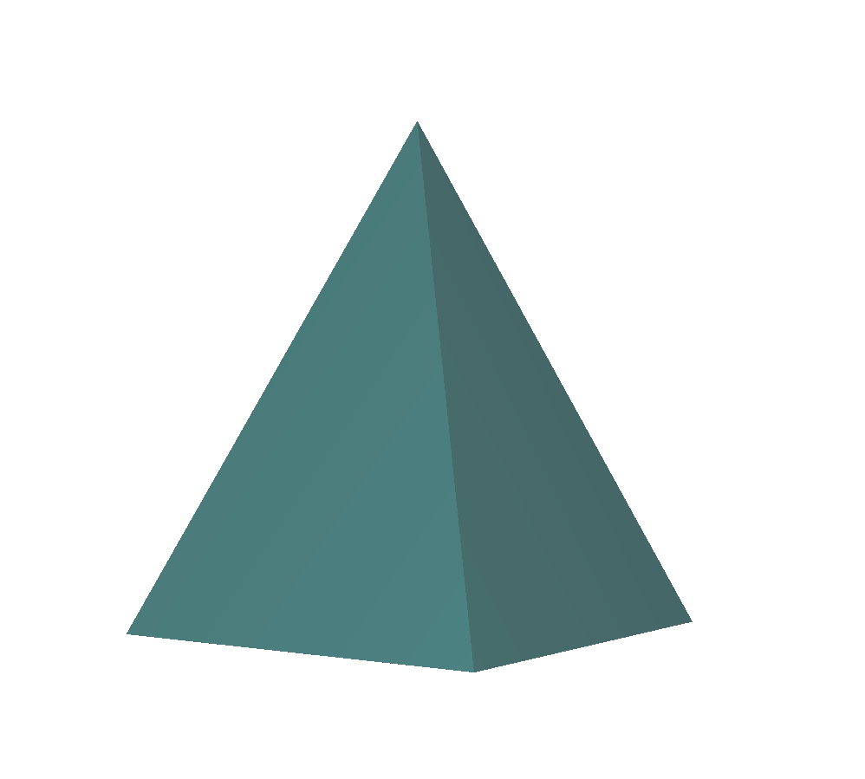
Figure 13 Pyramid as viewed in Myriad 3D Reader

iii. Torus
This file is from the VRML Sourcebook: torus.wrl

#VRML V2.0 utf8
# The VRML 2.0 Sourcebook
# Copyright (c) 1997
# Andrea L. Ames, David R. Nadeau, and John L. Moreland
Shape {
appearance Appearance {
material Material {
diffuseColor 1.0 0.0 1.0
}
}
geometry Extrusion {
creaseAngle 1.57
beginCap FALSE
endCap FALSE
crossSection [
# Circle
1.00 0.00, 0.92 -0.38,
0.71 -0.71, 0.38 -0.92,
0.00 -1.00, -0.38 -0.92,
-0.71 -0.71, -0.92 -0.38,
-1.00 -0.00, -0.92 0.38,
-0.71 0.71, -0.38 0.92,
0.00 1.00, 0.38 0.92,
0.71 0.71, 0.92 0.38,
1.00 0.00
]
spine [
# Circle
2.00 0.0 0.00, 1.85 0.0 0.77,
1.41 0.0 1.41, 0.77 0.0 1.85,
0.00 0.0 2.00, -0.77 0.0 1.85,
-1.41 0.0 1.41, -1.85 0.0 0.77,
-2.00 0.0 0.00, -1.85 0.0 -0.77,
-1.41 0.0 -1.41, -0.77 0.0 -1.85,
0.00 0.0 -2.00, 0.77 0.0 -1.85,
1.41 0.0 -1.41, 1.85 0.0 -0.77,
2.00 0.0 0.00,
]
}
}

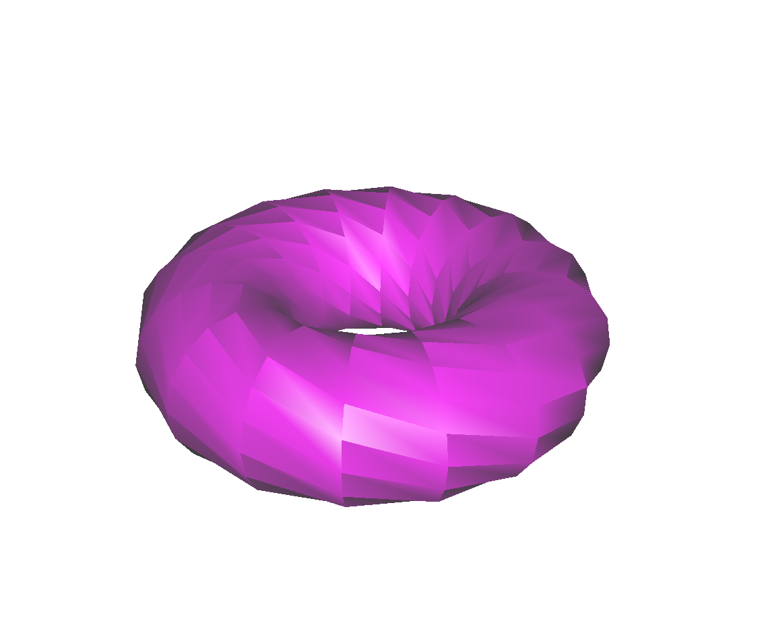
Figure 14 Torus

Index

Source, http://www.spacedaily.com/news/mars-weather-02a.html

