Simulation Demonstrations

- Rover Body with 128micron particles (Gaussian diameter, sigma=20micron), top surface:
java -mx512m Lander Demo_RoverBody_128micron_TOP.cfg

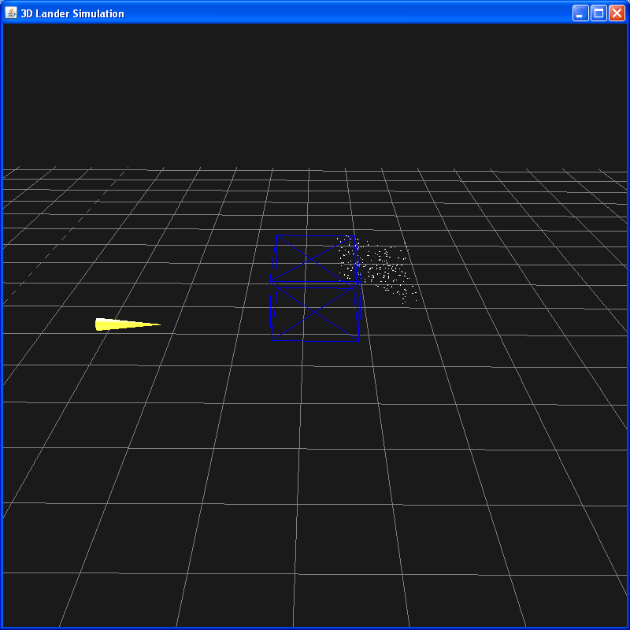

- As (1) but all surfaces sprinkled:

java -mx512m Lander Demo_RoverBody_128micron_ALL.cfg

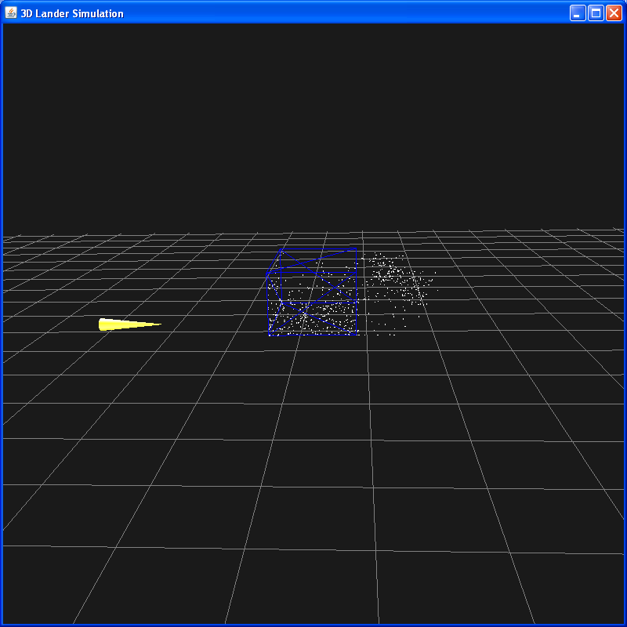

- As (2) but using CLEANROOM 100 specification

java -mx512m Lander Demo_RoverBody_Cleanroom100_ALL.cfg

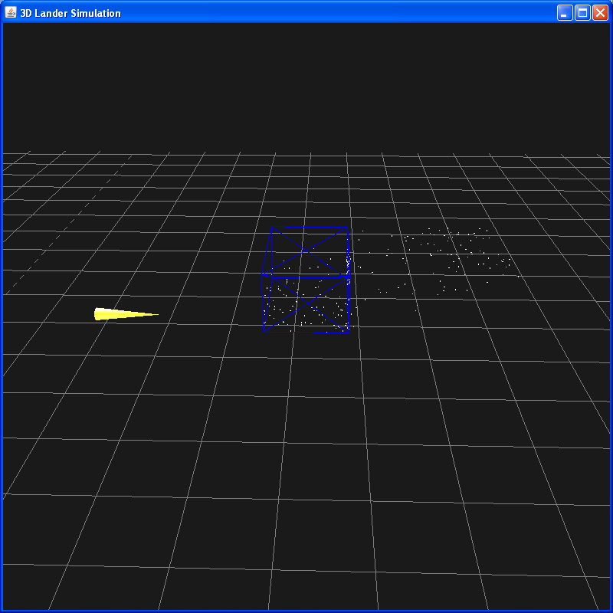

- As (2) but with particle density 1000 kg/m^3 and Detachment/LeadingEdge (set wind to e.g 4m/s not all particles come off)

java -mx512m Lander Demo_RoverBody_128micron_TOP_DF.cfg

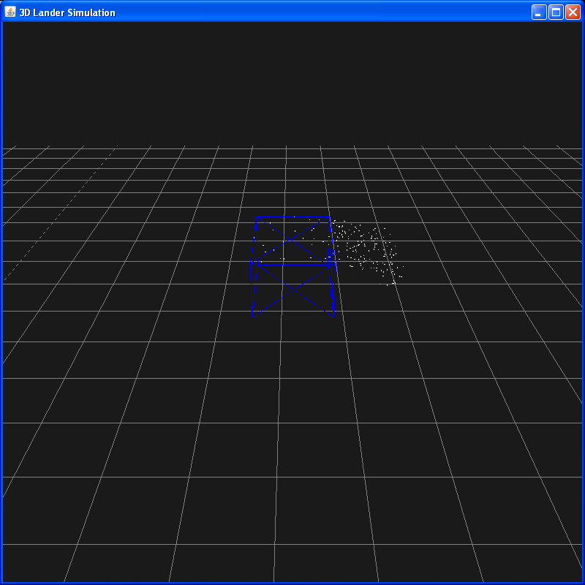

- Pyramid

java -mx512m Lander Demo_Pyramid_128Micron_ALL.cfg
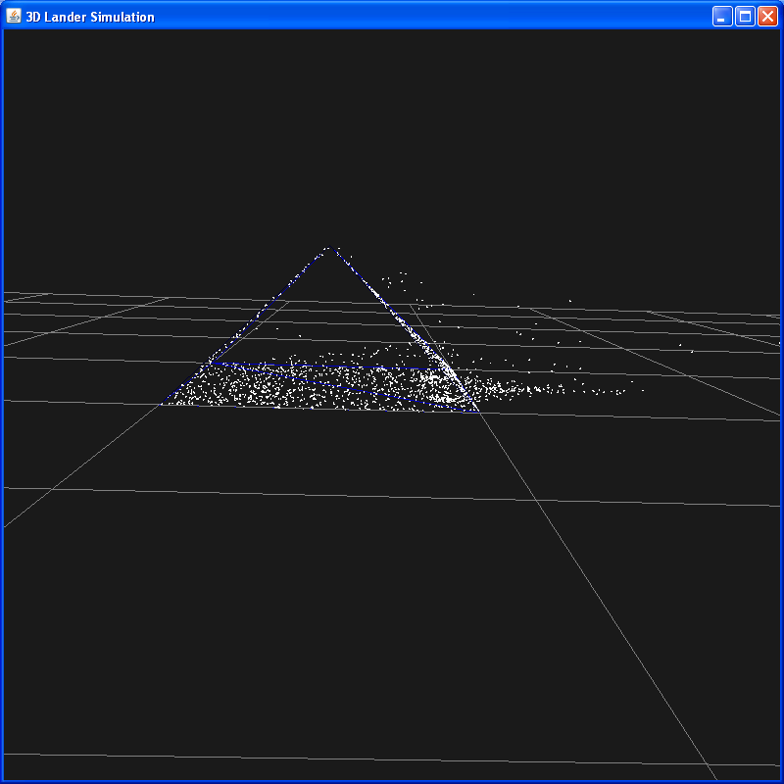

- Pyramid showing normals, and tracks
java -mx512m Lander Demo_Pyramid_128Micron_ALL_TRACKS.cfg

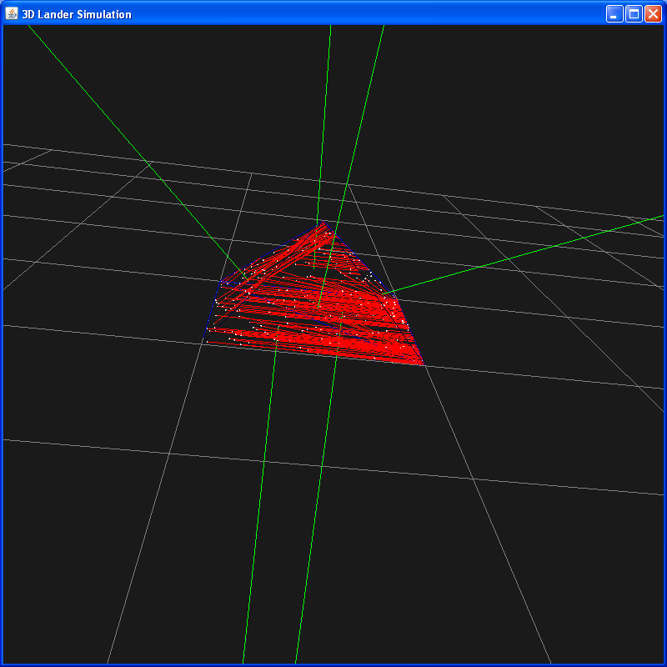

- Full Lander, on Mars, Cleanroom 100

java -mx512m Lander Demo_Lander_Mars.cfg

Total Surface area of geometry = 37.50667045055178m^2
Generated 666 particles
1-2 microns: 230.0
2-4 microns: 185.0
4-8 microns: 142.0
8-16 microns: 73.0
16-32 microns: 28.0
32-64 microns: 8.0
64-128 microns: 0.0
128-256 microns: 0.0

