UltraLight Optical Switching Fabric
Figure 2: UltraLight Optical Switching Fabric
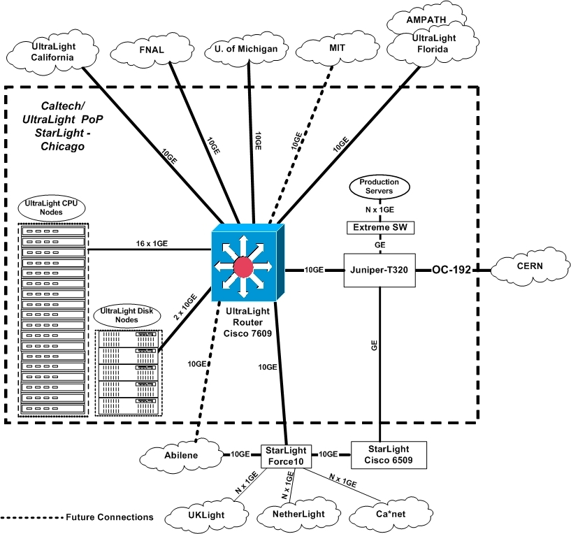

UltraLight MPLS Network Architecture
The MPLS network architecture for UltraLight will consist of a core of Cisco and Juniper Label Switch Routers (see Figure 3 below). These routers will interconnect the various edge sites where the Label Edge Routers will reside. Physically, the network will be connected in a star topology. It will provide basic transport services with and without bandwidth reservation, differentiated services support, and more advanced services such as Virtual Private Networks and Virtual Private LAN services. The UltraLight MPLS network will peer with other MPLS networks and use techniques such as priority queuing and shaping to interwork with those networks and provide end to end MPLS services for sites not directly connected into the UltraLight MPLS core. The UltraLight MPLS network will be integrated closely with the autonomous agents that make up the intelligent monitoring and management infrastructure.

Figure 3: UltraLight MPLS Network
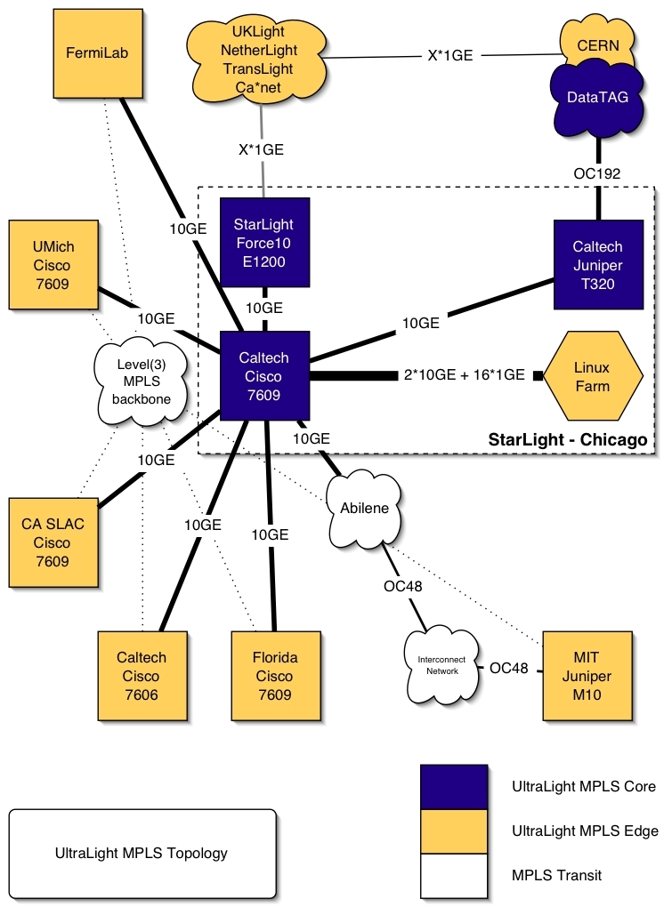

Caltech
Figure 4 California Network and Storage Servers Site Diagram
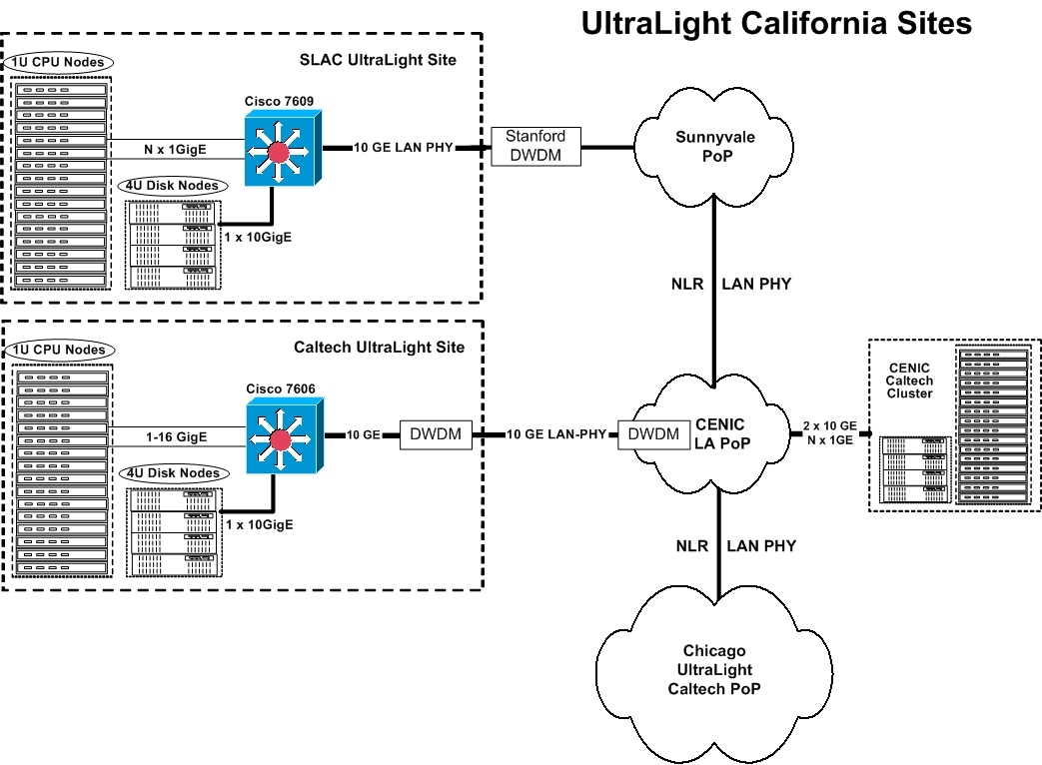

Leveraged Facilities at Caltech
The following lists detail Caltech's leveraged facilities:
Caltech Production Tier2 Cluster
- 12 ACME 6012PE (Dual Intel P4 Xeon 2.4GHz) 1U Rack-mounted server, 1GB PC2100 ECC SDRAM Reg. memory, 110/100, 1 Gigabit ethernet and 1 Syskonnect Gigabit card, ATI Rage XL PCI graphic controller, 1 Maxtor IDE 80 GB 7200 RPM drive
- 1 Dell PowerEdge 4400 Rack-mounted server dual Intel Xeon PIII 1 GHz processors 2 GB PC133 SDRAM main memory, 1 Intel 10/100 ethernet and 2 Syskonnect cards, ATI 3D Rage graphics controller, Adaptec SCSI 39160 and AHA- 2940U2 cards, 7 SCSI internal hard drives
- 20 2U Rack-mounted compute nodes with dual 800MHz Pentium III processors, 512 MB memory 10/100 Ethernet, 2x36 GB disk drives
- 1 4U Winchester FlashDisk OpenRAID rack-mounted SCSI RAID storage with total capacity of 3 TB
- Dell Powerconnect 5224 Rackmounted managed configurable network switch with 24 10/100/1000Mbps (RJ-45 connector) and 4 SPF fiber ports

Caltech Athlon cluster (DGT)
- A.Serv 1U-A1210 Rack Server, Dual AMD Athlon 1900+ processors on Tyan S2462NG K7 Thunder motherboard, 1 GB PC2100DDR ECC Register memory, 1 Intel Pro/1000T Gigabit
- and one 3Com 10/100 ethernet ports
- A.Serv 2U-2200 Rack Server, Dual AMD Athlon 1900+processors on Tyan S2466N Tiger MPX motherboard, 512 MB PC2100 DDR ECC Registered memory, 1 Intel Pro/1000T Gigabit and one 3Com 10/100 ethernet ports, ATI XPERT PCI XL video chipset
- 2 Asante IntraCore 65120-12G gigabit switches
- 2 Asante IntraCore 65120-2G gigabit switches

Caltech New Tier2 Cluster
- 25 1U rackmount servers based on Supermicro X5DPE-G2 motherboard, Dual Intel Xeon 2.8 GHz CPUs with 512K cache and 533 MHz FSB, 1GB PC2100 ECC Reg. memory, onboard Intel dual 82546EB gigabit ethernet controller, Maxtor 80GB 7200 RPM hard drive, onboard ATIRAGE XL 8MB PCI graphics controller, slim FDD and CDROM drives.
- 1 4U rackmount 18 IDE bays disk server on Supermicro X5DPE-G2 motherboard, Dual Intel Xeon 3.06 GHz CPU with 512k cacche and 533 MHz FSB, 2GB PC2100 ECC Reg. memory, onboard Intel dual 82546EB gigabit Ethernet controller, 8 Seagate 160GB SATA 7200 RPM and 1 Maxtor 80 GB IDE hard drives, 2 3Ware 8500-8 RAID controller, onboard ATI RAGE XL 8MB PCI graphic controller, slim FDD and CDROM drives.
- 1 4U rackmount 18 IDE bays disk server on Supermicro X5DPE-G2 motherboard, Dual Intel Xeon 3.06 GHz CPU with 512k cacche and 533 MHz FSB, 2GB PC2100 ECC Reg. memory, onboard Intel dual 82546EB gigabit Ethernet controller, 15 Maxtor 200GB 7200 RPM and 1 Maxtor 80 GB IDE hard drives, 2 3Ware 7500-8 RAID controller, onboard ATI RAGE XL 8MB PCI graphic controller, slim FDD and CDROM drives.
- 1 1U rackmount server based on Supermicro X5DPE-G2 motherboard, Dual Intel Xeon 2.4 GHz CPUs with 512K cache and 533 MHz FSB, 1GB PC2100 ECC Reg. memory, onboard Intel dual 82546EB gigabit ethernet controller, Maxtor 80GB 7200 RPM hard drive, onboard ATIRAGE XL 8MB PCI graphics controller, slim FDD and CDROM drives.

Caltech Network Servers
- 2 4U Rackmount server with Intel dual P4 Xeon 2 2.2 GHz processors on Supermicro P4DP6 motherboard, 2 GB ECC Registerd DDR memory Intel 7500 Chipset, 2 Syskonnect gigabit cards, 2x36 GB SCSI disk drives, ATI XL graphics card
- 1 2U Rack-mounted server with Intel dual P4 Xeon 1 2.2 GHz processors on Supermicro P4DP8-G2 motherboard, Intel E700 chipset, 2 GB PC2100 ECC Registered memory, 1 Syskonnect card, ATI Rage XL PCI graphic controller, 2x36 GB SCSI disk drives
- 12 ACME 6012PE (Dual Intel P4 Xeon 2.4GHz) 1U Rack- mounted server, 1GB PC2100 ECC SDRAM Reg. memory, 1 10/100, 1 Gigabit ethernet and 1 Syskonnect Gigabit card, ATI Rage XL PCI graphic controller, 1 Maxtor IDE 80 GB 7200 RPM drive
- 4 4U Rack-mounted Disk Server based on Supermicro P4DPE- G2 motherboard with dual Intel P4 Xeon 2.4 GHz processors, Intel E7500 chipset, 2 GB of PC2100 ECC Registered DDR memory, 2 Syskonnect cards, ATI Rage XL PCI graphic controller, 2 3ware 7500-8 RAID controllers, 16 Western Digital IDE disk drives for RAID and 1 for system
- 6 4U Rack-mounted Server based on Supermicro P4DP8-G2 motherboard with dual Intel P4 Xeon 2.2 GHz processors, 2 GB of PC2100 ECC Registered DDR memory, Intel E7500 chipset, ATI Rage XL PCI graphic controller, 2 Intel 82546EB copper gigabit and 2 Syskonnect gigabit cards, ATI Rage XL PCI graphics controller, 2x36 GB SCSI disk drives
- 4 4U Rack-mounted Disk Server based on Supermicro P4DPE-G2 motherboard with dual Intel P4 Xeon 2.4 GHz processors, Intel E7500 chipset, 2 GB of PC2100 ECC Registered DDR memory, 2 Syskonnect cards, ATI Rage XL PCI graphic controller, 2 3ware 7500-8 RAID controllers, 16 Western Digital IDE disk drives for RAID and 1 for system
- 2 4U Rack-mounted Server based on Supermicro P4DP8-G2 motherboard with dual Intel P4 Xeon 2.2 GHz processors, 2 GB of PC2100 ECC Registered DDR memory, Intel E7500 chipset, ATI Rage XL PCI graphic controller, 2 Intel 82546EB copper gigabit and 2 Syskonnect gigabit cards, ATI Rage XL PCI graphics controller, 2x36 GB SCSI disk drives

Caltech CENIC Network Servers
- 12 Dual IntelR XeonT processors, 2.40GHz with 512K L2 cache, SuperMicro P4DPR-I Motherboard, 1 GB PC2100 DDR ECC Registered, 1 Intel 82550 fast Ethernet and 1 Gigabit ethernet on board, 1 Syskonnect Gigabit card, 80GB IDE Maxtor, 7200 RPM, 1*SysKonnect Gigabit Ethernet card SK-9843 SK-NET GE SX, 1U Rack-mounted server, 2.5Amps, 20V
- 2 Dual IntelR XeonT processors, 2.40GHz with 512K L2 cache, SuperMicro P4DPE-G2 Motherboard, 2 GB RAM, 2 3ware 7500-8 RAID controllers, 16 WesternDigital IDE disk drives for RAID and 1 for system, 2 Intel 82550 fast Ethernet, 2*SysKonnect Gigabit Ethernet card SK-9843 SK-NET GE SX, 4U Rack-mounted server, 480W to run 600W to spin up
- 1 Power Tower XL from Server Technology
- 2 Alacritech 1000x1F fiber single-port server accelerator with accelerated drivers for Windows 2000/XP/2003
- 2 Intel PRO/10GbE LR server adapter

Caltech StarLight Network Servers
- 6 Dual IntelR XeonT processors, 2.20GHz with 512K L2 cache,SuperMicro P4DP8-G2Motherboard, Intel E700 chipset, 1 GB RAM, PC2100 ECC Reg. DDR,Onboard Adaptec AIC-7902 dual channel Ultra320 SCSI controller, 2*Seagate 36.7GB SCSI 80pin 10KRPM Ultra 160, On board Intel 82546EB dual port Gigabit Ethernet controller, 2*SysKonnect Gigabit Ethernet card SK-9843 SK-NET GE SX, 4U Rack-mounted server, 420W Power supply.
- 2 Dual IntelR XeonT processors, 2.40GHz with 512K L2 cache, SuperMicro P4DPE-G2 Motherboard, 2 GB RAM, PC2100 ECC Reg. DDR, 2 3ware 7500-8 RAID controllers, 16 WesternDigital IDE disk drives for RAID and 1 for system, 2 Intel 82550 fast Ethernet, 2*SysKonnect Gigabit Ethernet card SK-9843 SK-NET GE SX, 4U Rack-mounted server, 480W to run 600W to spin up

Caltech StarLight Network Equipment
- 1 Cisco 7606:Catalyst 6000 SU22/MSFC2 SERVICE PROVIDER W/VIP (supervisor) 2-port OC-12/STM-4 SONET/SDH OSM, SM-IR, with 4 GE Catalyst 6500 Switch Fabric Module (WS-C6500-SFM)
- 1 Cisco 7609: Catalyst 6000 SU22/MSFC2 SERVICE PROVIDER W/VIP (supervisor) 1-port OC-48/STM-16 SONET/SDH OSM, SM-SR, with 4 GE 4-port Gigabit Ethernet Optical Services Module, GBIC Catalyst 6500 10 Gigabit Ethernet Module with 1310nm long haul OIM and DFC card Catalyst 6500 16-port GigE module, fabric enable Catalyst 6500 Switch Fabric Module (WS-C6500-SFM) Role: Element of the multi-platforms testbed (Datatag project).
- 1 Cisco 2950 24 10/100 ports + 2*1000BASE-SX ports Role: Fast Ethernet switch for production with 2 Gbps uplinks.
- 1 Cisco 7507 One-port ATM enhanced OC-3c/STM1 Multimode PA (PA-A3-OC3MM) One-port Fast Ethernet 100BaseTx PA (PA-FE-TX) Two-port T3 serial PA enhanced (PA-2T3+) One-port Packet/SONET OC-3c/STM1 Singlemode (PA-POS-SM) Gigabit Ethernet Interface Processor, enhanced (GEIP+) One-port Packet/SONET OC-3c/STM1 Singlemode (PA-POS-SM) Role: Old router for backup and tests (IPv6 and new IOS software release tests).
- 1 Juniper M10 1 port SONET/SDH OC48 STM16 SM, Short Reach w/Eje 2 ports PE-1GE-SX-B (2*1 port Gigabit Ethernet PIC, SX Optics, with PIC ejector) Role: Element of the multi-platforms testbed (Datatag project). In particular, it is dedicated to level 2 services.
- 1 Extreme Summit 5i GbE Gigabit Ethernet switch with 16 ports Role: Network elements interconnection at Gbps speed.
- 1 Cisco 7204VXR Two-port T3 serial PA enhanced (PA-2T3+) Gigabit Ethernet Port Adapter (PA-GE) Role: Old router for backup and tests.
- 1 Alcatel 1670 (belong to CERN) 1*OC-48 port. 2 GBE ports Role: Element of the multi-platforms testbed. SONET multiplexer.
- 1 Alcatel 7770 (belong to CERN) 2 port OC-48 8 port OC-12 8 port GBE Role: Element of the multi-platforms testbed (Datatag project).

Caltech CERN Network Servers
- 2 Dual IntelR XeonT processors, 2.20GHz with 512K L2 cache,SuperMicro P4DP8-G2Motherboard, Intel E700 chipset, 1 GB RAM, PC2100 ECC Reg. DDR,Onboard Adaptec AIC-7902 dual channel Ultra320 SCSI controller, 2*Seagate 36.7GB SCSI 80pin 10KRPM Ultra 160, On board Intel 82546EB dual port Gigabit Ethernet controller, 2*SysKonnect Gigabit Ethernet card SK-9843 SK-NET GE SX, 4U Rack-mounted server, 420W Power supply.
- 4 Dual IntelR XeonT processors, 2.40GHz with 512K L2 cache, SuperMicro P4DPE-G2 Motherboard, 2 GB RAM, PC2100 ECC Reg. DDR, 2 3ware 7500-8 RAID controllers, 16 WesternDigital IDE disk drives for RAID and 1 for system, 2 Intel 82550 fast Ethernet, 2*SysKonnect Gigabit Ethernet card SK-9843 SK-NET GE SX, 4U Rack-mounted server, 480W to run 600W to spin up

Caltech CERN Network Equipment (belong to CERN)
- 1 Cisco 7606 4-port Gigabit Ethernet Optical Services Module, GBIC 2-port OC-12/STM-4 SONET/SDH OSM, SM-IR, with 4 GE Catalyst 6500 Switch Fabric Module (WS-C6500-SFM) Role: Production router at CERN connected to the OC12 circuit.
- 1 JuniperM10 2 ports PE-1GE-SX-B (2*1 port Gigabit Ethernet PIC, SX Optics, with PIC ejector) Role: Element of the multi-platforms testbed (Datatag project). In particular, it is dedicated to level 2 services.
- 1 Cisco 7609 Catalyst 6000 SU22/MSFC2 SERVICE PROVIDER W/VIP (supervisor) 1-port OC-48/STM-16 SONET/SDH OSM, SM-SR, with 4 GE 4-port Gigabit Ethernet Optical Services Module, GBIC Role: Element of the multi-platforms testbed (Datatag project). In particular, it will be dedicated to QoS.
- 1 Cisco 7507 One-port ATM enhanced OC-3c/STM1 Multimode PA (PA-A3-
- OC3MM) One-port Fast Ethernet 100BaseTx PA (PA-FE-TX) Two-port T3 serial PA enhanced (PA-2T3+) One-port Packet/SONET OC-3c/STM1 Singlemode (PA-POS-SM) Gigabit Ethernet Interface Processor, enhanced (GEIP+) One-port Packet/SONET OC-3c/STM1 Singlemode (PA-POS-SM) Role: Old router for backup and tests (IPv6 and new IOS software release tests).
- 1 Juniper M10 1 port SONET/SDH OC48 STM16 SM, Short Reach w/Eje 2 ports PE-1GE-SX-B (2*1 port Gigabit Ethernet PIC, SX Optics, with PIC ejector) Role: Element of the multi-platforms testbed (Datatag project). In particular, it is dedicated to level 2 services.
- 1 Cisco 7609 Catalyst 6000 SU22/MSFC2 SERVICE PROVIDER W/VIP (supervisor) 1-port OC-48/STM-16 SONET/SDH OSM, SM-SR, with 4 GE. 4-port Gigabit Ethernet Optical Services Module, GBIC Role: Element of the multi-platforms testbed (Datatag project). In particular, it will be dedicated to QoS.
- 1 Alcatel 1670 1*OC-48 port 2 GBE ports Role: Element of the multi-platforms testbed (Datatag project). SONET multiplexer.
- 1 Alcatel 7770 2 port OC-48. 8 port OC-12. 8 port GBE Role: Element of the multi-platforms testbed (Datatag project).

Caltech VRVS System
- 1 VRVS.ORG web server CPU Dual Pentium III (Coppermine) 1GHZ RAM 512M HD ~32G
- 1 VRVS 2.5 demo and development server CPU Single Pentium III (Coppermine) 845MHZ RAM 512M HD ~33G
- 1 VRVS 3.0 web server CPU Dual Intel(R) XEON(TM) CPU 2.20GHz RAM 2G HD ~65G
- 1 VRVS MPEG2 MCU and web server CPU Single Pentium III (Coppermine) 800MHZ RAM 256M HD ~4.3G
- 1 VRVS CALTECH reflector CPU Single Pentium III (Coppermine) 700MHZ RAM 256M HD ~16G
- 1 VRVS 3.0 development server CPU Dual Intel(R) XEON(TM) CPU 2.40GHz RAM 1G HD ~65G
- 1 VRVS 3.0 CALTECH StarLight reflector CPU Dual Intel(R) XEON(TM) CPU 2.40GHz RAM 1G HD ~65G

Caltech MonaLisa Monitoring System
- 1 Locate at CACR: 1U rackmount servers based on Supermicro X5DPE-G2 motherboard, Dual Intel Xeon 2.8 GHz CPUs with 512K cache and 533 MHz FSB, 1GB PC2100 ECC Reg. memory, onboard Intel dual 82546EB gigabit Ethernet controller, Maxtor 80GB 7200 RPM hard drive, onboard ATIRAGE XL 8MB PCI graphics controller, slim FDD and CDROM drives.
- 1 Locate at Chicago: 1U rackmount servers based on Supermicro X5DPE-G2 motherboard, Dual Intel Xeon 2.8 GHz CPUs with 512K cache and 533 MHz FSB, 1GB PC2100 ECC Reg. memory, onboard Intel dual 82546EB gigabit Ethernet controller, Maxtor 80GB 7200 RPM hard drive, onboard ATIRAGE XL 8MB PCI graphics controller, slim FDD and CDROM drives.

Caltech TeraGrid Network Equipment at CACR
- 1 ONI Systems Online Metro DWDM
- 1 Juniper T640: 3 STM-64/OC-192 SONET SMF-SR-2 3 Ethernet 10GBASE-LR
- 1 Force 10 E1200:2 LC-ED-10GEL-2Y 10GBASE-LR module 1 LC-ED-RPM management module 6 LC-ED-1GE-24P 24 port GbE module

Caltech TeraGrid Network Equipment at CENIC
- 1 ONI Systems Online Metro DWDM
- 1 Juniper T640:3 STM-64/OC-192 SONET SMF-SR-2 3 Ethernet 10GBASE-LR

Internet2

Internet2's contributions will encompass several resources.

- A special experimentally focused interconnection in Chicago of UltraLight to Internet2's 10 Gb/s Abilene backbone network. At a minimum, this will be done using Abilene's existing 10 Gb/s connection to the StarLight switch. If a separate fiber pair is made available, this will be done with a new dedicated 10 Gb/s connection to the UltraLight switch.
- Leveraging Internet2's role as a founding member of the NLR effort, engineering resources will be made available to help with the design and engineering of UltraLight's NLR-based facilities.
- The one-way delay measurement technology as well as other techniques developed in the Abilene Observatory project will be made available for us in the performance measurement activities of UltraLight.
- Leveraging Internet2's capabilities in end-to-end performance, engineering resources will be made available to study the performance achieved for aggressive applications over the UltraLight facility, and to compare it with the performance achieved over the Internet2 infrastructure.
- Internet2 will collaborate in the consideration of specific experimentally focused MPLS tunnels between designated sites on the UltraLight facility and on the Internet2 infrastructure, both to broaden the reach of UltraLight's experimental facility and to test the relative efficacy of the MPLS-based techniques developed as part of the UltraLight project.

More generally, Internet2 will engage with UltraLight in understanding
how to support UltraLight applications most effectively, both in the
current Internet2 production infrastructure, in the proposed UltraLight
experimental infrastructure, and in future forms of Internet2's production infrastructure.

University of Florida
Figure 5: Florida UltraLight Optical Network
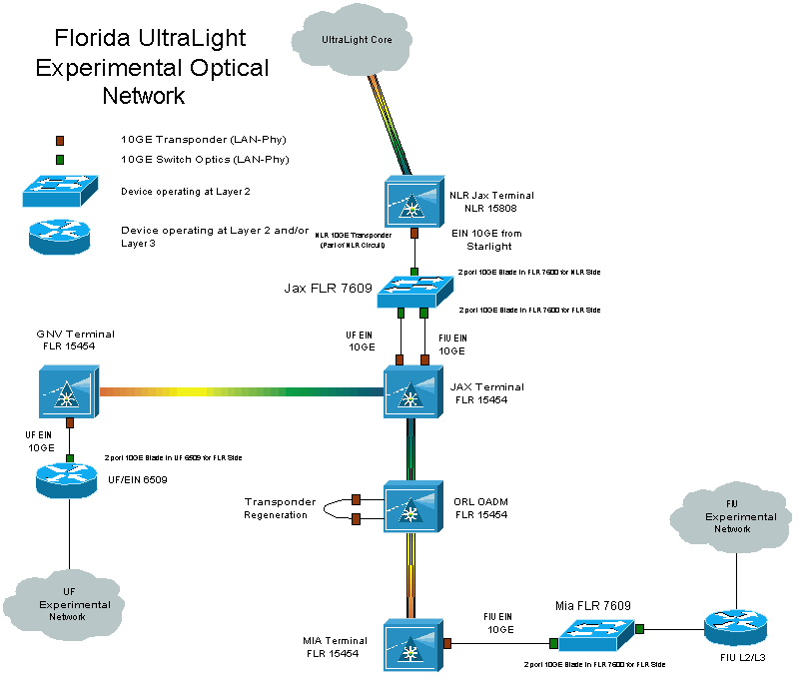

University of Florida and Florida International University will use Florida’s emergent Florida Lambda Rail (FLR) optical network to create an experimental network to connect to UltraLight. FLR connects to National Lambda Rail (NLR) in Jacksonville. UFL and FIU each will provision 10GbE LAN-PHY wavelengths to the optical cross-connect (OXC) in Jacksonville, from where UFL and FIU will share another 10GbE LAN-PHY wavelength across NLR will connect Florida’s UltraLight network to the UltraLight optical core.

Leveraged Facilities at UFL
The University of Florida computing equipment is configured as a prototype Tier2 site as part of the 5 Tier global computing infrastructure for the CMS experiment at the LHC. It includes many rack-mounted servers and several TeraBytes of RAID storage. The system is intended for use as a general purpose computing environment for LHC physicists. Other tasks include large scale production of Monte Carlo simulations, high speed network transfers of object collections for analysis, and general prototyping and development efforts in the context of the work on the International Virtual Data Grid Laboratory (iVDLG), which is setting up a global grid testbed. The Tier2 includes a fully up to date software environment with the latest versions of operating systems, firmware, Grid software and tools, PPDG, GriPhyN and iVDGL software.

The Florida Tier2 and Network equipment details follow:
- 70 dual CPU compute servers, 2U (P3,1.0GHz,0.5 BB,75GB,1x100 Mbps)
- 50 dual CPU compute servers, 1U (P4,2.6GHz,1.0 GB,80GB,2x1 Gbps)
- 2 dual CPU head nodes, 2U (P3,1.0GHz,1.0 GB,80GB,2x100 Mbps network
- 2 dual CPU head nodes, 1U (P4,2.6GHz,2.0 GB,160GB,2x1 Gbps network 0.5 TB RAID (Sun T3 , Fibrechannel) 1.0 TB RAID (Winchester Flashdisk, Fibrechannel, 1Gbps) 4.8 TB RAID (2 IDE RAID, 2.4TB apiece, 2 CPU, 16x180 disks, 1x1Gbps) 9.0 TB RAID (2 IDE RAID, 4.5TB apiece, 2 CPU, 16x320 disks, 2x1Gbps)
- 1 Cisco 4006 switch with 4 blades
- 3 Dell 5324 switches

Campus backbone = 2x1 Gbps
Wide area connection = 622 Mbps to Abilene

Florida International University

FIU to UltraLight Connectivity Description
FIU will connect to UltraLight through a 10GbE LAN-PHY wavelength interconnecting Miami to Jacksonville, then sharing a 10GbE LAN-PHY wavelength to the UltraLight optical core with UFL (see Figure 5 above). The connection in Miami will be from the NAP Of The Americas, where the AMPATH PoP is located. AMPATH serves as the international exchange point for research and education networks in the Americas.

Leveraged Facilities at FIU
FIU is the lead institution, in collaboration with Caltech, University of Florida and Florida State University, proposing to develop an inter-regional Center for High-Energy Physics Research Education and Outreach (CHEPREO). CHEPREO is a 5-year program, that in year 1, would establish an STM-4 (622 Mbps) SDH-based transport service between Miami and Rio. CHEPREO would also establish a Tier3 CMS Grid facility in Miami for FIU. The STM-4 circuit would be used for research and experimental networking activities, and production. Through the CHEPREO program, UltraLight could leverage the availability of an experimental network to South America. Likewise, the Tier1 facility in Rio and Brazil’s HENP community can access UltraLight for connectivity to the Global Grid community. Figure 5 shows how the emergent Grid Physics Tier1 facility at the State University of Rio de Janeiro (UERJ) would be connected to Miami and UltraLight.
Figure 6: UltraLight International Connection to Brazil (years 1-3)
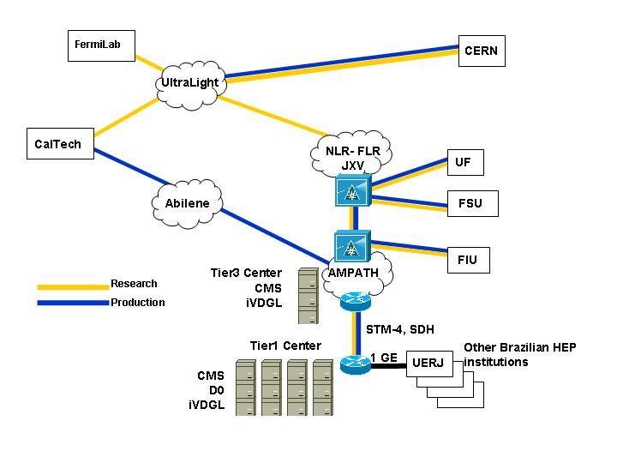
Leveraging the experimental network in Florida, and then transiting NLR, Brazil and South America would be able to participate in UltraLight. By year 3 or possibly sooner, the load on the inter-regional STM-4 circuit is expected to reach capacity. As soon as possible, this circuit should be upgraded to a 2.5G or 10G wavelength and a Layer2 connection extended to South America, as is to other UltraLight Peer Sites. The following figure shows L2-L3 equipment by which South America can connect to the UltraLight optical fabric.
Figure 7: UltraLight International Connection to Brazil (years 4-5)
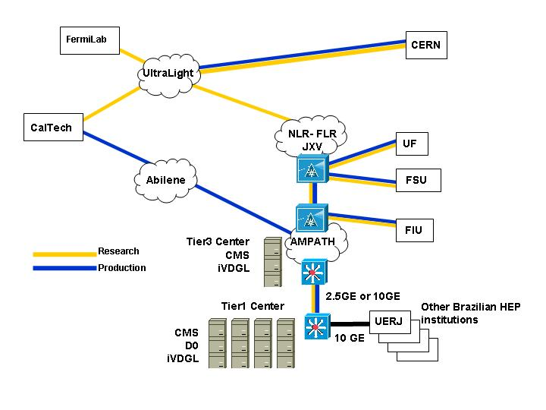

University of Michigan
Figure 8: University of Michigan Network Site Diagram
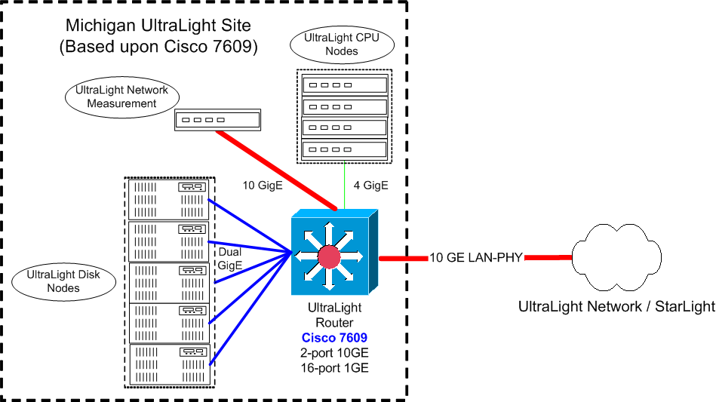

University of Michigan to UltraLight Connectivity Description
As shown in the above figure, Michigan will have a 10 GE LAN-PHY connection to UltraLight via a University of Michigan owned fiber from Ann Arbor to StarLight in Chicago. We intend to populate the Michigan UltraLight PoP with three kinds of equipment:
- Network storage servers based upon commodity components, capable of driving the full 10 Gigabits/sec of UltraNet bandwidth via numerous Gigabit Ethernet connections operating in parallel
- ,A small number of CPU nodes connected at 1 Gigabit.
- A network monitoring and testing station connected at 10 Gigabits
Michigan will provide the wave transport for the UltraLight 10GE connection.

Leveraged Facilities at the University of Michigan
Michigan hosts one of eight US ATLAS GRID testbed sites. Our site is currently composed of 10 dual cpu systems, with memory ranging from 256 Mbytes up to 1 Gigabyte per system. The storage systems are a combination of SCSI and IDE RAID 5 configurations totaling over 2.5 terabytes of storage. Some of these nodes will be co-located at the Michigan UltraLight PoP. The Michigan Grid Research and Infrastructure Development (MGRID) group and the Center for Advanced Computing operates significant computational and storage resources that will available for use by the Ultralight project. This equipment will be used for infrastructure simulation, data backup for the University of Michigan Ultralight equipment, and for providing Ultralight access for NPACI and CAC users. The list of equipment includes:

- AMD Athlon MP Cluster Morpheus
67 computational nodes interconnected via Myrinet with a 3.5 TB storage subsystem.
50 nodes contain 100 Athlon MP 1600+ processors, 17 nodes contain 34 Athlon MP 2200+ processors. All nodes contain 2 GB of RAM. 63% of this system is dedicated to use by NPACI users.

- AMD Athlon MP Cluster Hypnos
154 compuational nodes, 128 of which are interconnected via Myrinet and the remainder connected via Ethernet. 128 of the nodes contain 256 Athlon 2000+ processors and 26 of the nodes contain 52 Athlon MP 2400+ processors. Each node contains 2GB of RAM and has access to a shared 1TB RAID. 80% of this system is dedicated to use by NPACI users.

- Intel Cluster Treehouse
32 compuational nodes interconnected via gigabit ethernet containing 64 Intel Pentium III
800 MHz processors. Each node contains 1GB of RAM.

- Tivoli Mass Storage System
72 TB mass storage system running IBM Tivoli software. This system will be used for backups for the University of Michigan Ultralight computational and storage nodes.

MIT/Haystack

Figure 9 MIT/Haystack Network Site Diagram
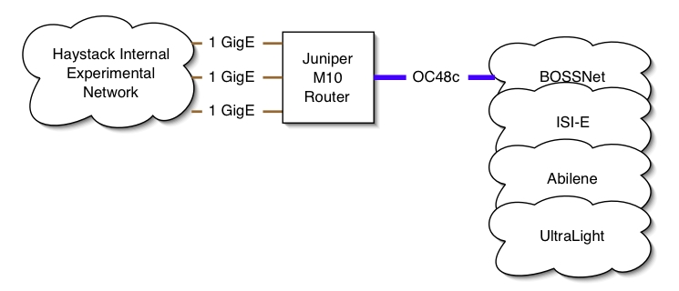

MIT/Haystack to UltraLight Connectivity Description
Option A:
MIT/Haystack is currently planning to connect into StarLight via Abilene. We will add an extra OC48c wavelength to our existing fiber connection into ISI-E. This path goes via GLOWnet and then BOSSnet into ISI-E in Arlington, VA. We plan to terminate there on a Juniper M40 router which would then connect directly into Abilene. This is subject to approval. Abilene would provide an IP-based Layer3 Transport service to StarLight.

Option B:
Our other alternative is to connect directly in to the Level 3 POP at 300 Bent St, Cambridge. In order to get to this POP, we would be required to add another wavelength to our existing connection, strip it off and re-direct through MIT campus to the Level 3 POP. From there we would connect directly over an NLR wavelength to Chicago.

Leveraged facilities at Haystack Observatory
The following existing facilities will be leveraged in the execution of the work under this proposal:
- Mark 4 VLBI correlator facility, supported by NASA and NSF
- Juniper M10 router; on loan from Caltech
- Mark 5 e-VLBI data systems – supported by NASA, NSF and DARPA (http://web.haystack.mit.edu/mark5/Mark5.htm)
- Glownet (fiber connection from Haystack Observatory to MIT Lincoln Lab) –supported by MIT Lincoln Laboratory, including various routers and switches (ftp://web.haystack.edu/pub/e-vlbi/demo_report.pdf)
- Bossnet (fiber connection from MIT Lincoln Lab to ISI-E) – supported by MIT Lincoln Laboratory, including various routers and switches (http://www.ll.mit.edu/AdvancedNetworks/bossnet.html)
- Facilities of ISI-E – supported by Information Sciences Institute of USC, including routers and switches (http://www.east.isi.edu/)
- Facilities of MAX – supported by the Mid-Atlantic Crossroads consortium, including routers and switches (http://www.maxgigapop.net/)

