Global Lambdas for Particle Physics Analysis
SC|05 Bandwidth Challenge Entry Caltech-CERN-Florida-FNAL-Manchester-Michigan-SLAC, Brazil, Korea, Japan, et al.

CERN's Large Hadron Collider experiments: Data/Compute/Network Intensive
Discovering the Higgs and SuperSymmetry - with a Global Grid
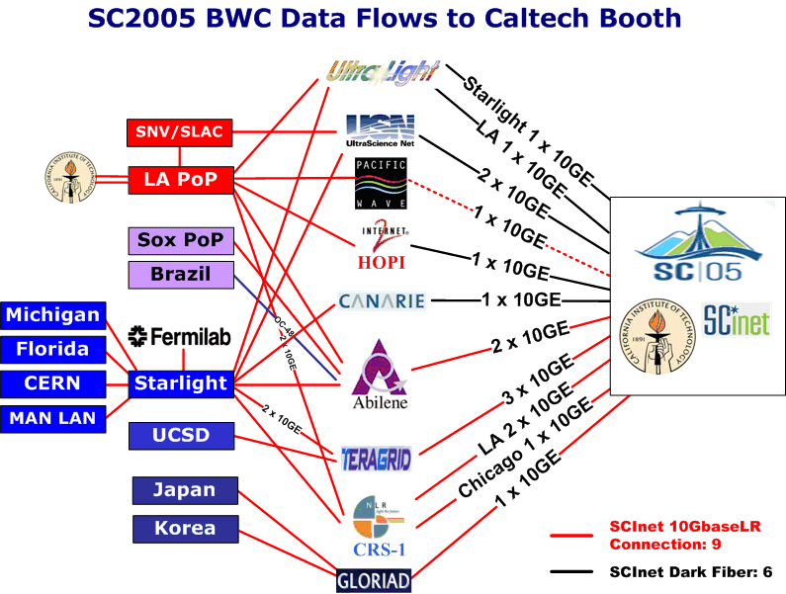
Worldwide collaborations of physicists working together

Our entry will demonstrate high speed transfers of physics data between host labs and collaborating institutes in the USA and worldwide. Caltech and FNAL are major participants in the CMS collaboration at CERN’s Large Hadron Collider (LHC). SLAC is the host of the BaBar collaboration. Using state of the art WAN infrastructure and Grid-based Web Services based on the LHC Tiered Architecture, our demonstration will show real-time particle event analysis requiring transfers of Terabyte-scale datasets.

We propose to saturate at least fifteen lambdas at Seattle, full duplex (potentially over 300 Gbps of scientific data).

The lambdas will carry traffic between Caltech, FNAL, SLAC, CERN and other partner Grid Service sites in Korea, Brazil and Japan. We will monitor the WAN performance using Caltech's MonALISA agent-based system. The analysis software will use a suite of Grid-enabled Analysis tools developed at Caltech and the University of Florida. There will be a realistic mixture of streams: those due to the transfer of the TeraByte event datasets, and those due to a set of background flows of varied character absorbing the remaining capacity. The intention is to simulate the environment in which distributed physics analysis will be carried out at the LHC. We expect to easily beat our SC2004 record of ~100Gbits/sec (roughly equivalent to downloading 1000 DVDs in less than an hour).

Contacts

Caltech: Julian Bunn (Julian.Bunn@caltech.edu)
Harvey Newman (newman@hep.caltech.edu)
SLAC: Les Cottrell (cottrell@slac.stanford.edu)
FNAL: Matt Crawford (crawdad@fnal.gov)
U. Florida: Rick Cavanaugh (cavanaug@phys.ufl.edu)
Manchester: Richard Hughes-Jones (R.Hughes-Jones@manchester.ac.uk)
Michigan: Shawn McKee (smckee@umich.edu)

